MINISTRY OF EDUCATION & TRAINING
HO CHI MINH CITY UNIVERSITY OF ECONOMICS AND FINANCE

FINAL REPORT
JAVA TECHNOLOGY

RESTAURANT AND FOOD ORDER MANAGEMENT SYSTEM

FINAL REPORT

Ho Chi Minh City – 2026
MINISTRY OF EDUCATION & TRAINING
HO CHI MINH CITY UNIVERSITY OF ECONOMICS AND FINANCE

FINAL REPORT
WEB APPLICATION DEVELOPMENT

RESTAURANT AND FOOD ORDER MANAGEMENT SYSTEM

Member:
Nguyễn Thị Cẩm Như - 235051586
Vũ Ngọc Khoa - 235057373
Huỳnh Xuân Nhi - 235051933
Nguyễn Hiếu Nghĩa - 235057450

Major: Information Technology

SUPERVISOR(S): Hoang Van Hieu, Msc.
Ho Chi Minh City – 2026

ACKNOWLEDGEMENT
First and foremost, we would like to express our sincere gratitude to our supervisor, Mr. Hoang Van Hieu, for his valuable guidance, constructive feedback, and support throughout the development of our project, Restaurant and Food Order Management System. His suggestions and recommendations helped us improve our understanding of web application development and address various challenges during the implementation process.
We would also like to thank the lecturers of the Ho Chi Minh City University of Economics and Finance for providing us with the fundamental knowledge and practical skills necessary to complete this project. The knowledge gained during our studies has been an important foundation for analyzing requirements, developing application functionalities, and preparing this report.
Furthermore, we appreciate the cooperation and contributions of all team members. Through discussions, task allocation, implementation, and testing, we were able to apply our knowledge of programming, database management, and web development to a practical project.
Although we have made every effort to complete the project and report carefully, certain limitations may remain. We sincerely appreciate any comments and suggestions that could help us improve our work in the future.
Finally, we would like to express our appreciation to everyone who has supported and encouraged us throughout the completion of this project.

LETTER OF GUARANTEE
We hereby declare that the project entitled “Restaurant and Food Order Management System” is the result of our group's work, carried out as part of the Web Application Development course at the Ho Chi Minh City University of Economics and Finance.
We guarantee that the content of this report has been prepared for academic purposes and reflects our understanding, implementation, and evaluation of the project. The descriptions of the system's functionalities, development technologies, implementation process, and testing activities are intended to correspond to the project developed by our group.
Any materials, references, or external resources used in preparing this report are acknowledged where applicable. We understand the importance of academic integrity and take responsibility for the accuracy and originality of the work presented in this report.
We also acknowledge that the project may have limitations in terms of functionality, testing coverage, and further development. Any statements concerning implemented features and testing results should be understood within the actual scope and status of the project.
Finally, we would like to express our heartfelt gratitude once again to everyone who has supported us throughout the completion of this project.
Thank you very much.
Nguyen Thi Cam Nhu
Vu Ngoc Khoa
Huynh Xuan Nhi
Nguyen Hieu Nghia

TABLE OF CONTENTS
TABLE OF CONTENTS i
LIST OF TABLES iv
LIST OF FIGURES vii
INTRODUCTION 1
Chapter 1 . OVERVIEW OF RESTAURANT AND FOOD ORDER MANAGEMENT SYSTEM 4
1.1 Project Overview 4
1.2 Current Situation and Problem Statement 5
1.2.1 Traditional Restaurant Management 5
1.2.2 Limitations of the Existing System 6
1.3 Proposed Solution 7
1.4 System Objectives 8
1.5 System Users 9
1.5.1 Administrator 9
1.5.2 Customer 10
1.5.3 Restaurant Staff 11
1.5.4 User Permission Summary 11
1.6 Development Environment and Technologies 12
1.6.1 C# Programming Language 13
1.6.2 ASP.NET MVC 5 Framework 13
1.6.3 Microsoft SQL Server 14
1.6.4 Entity Framework / ADO.NET (Data Access) 14
1.6.5 HTML5, CSS3, and Bootstrap 14
1.6.6 JavaScript and jQuery 15
1.6.7 Microsoft Visual Studio and SQL Server Object Explorer 15
Chapter 2 . THEORETICAL BACKGROUND AND REQUIREMENT ANALYSIS 16
2.1 Theoretical background 16
2.1.1 C# Programming Language 17
2.1.2 ASP.NET MVC Framework 17
2.1.3 Entity Framework 18
2.1.4 Razor View 20
2.1.5 Bootstrap 20
2.1.6 Model–View–Controller Architecture 21
2.1.7 Authorization and Security Mechanism 21
2.2 System Architecture Analysis 22
2.2.1 Presentation Layer 23
2.2.2 Controller Layer 23
2.2.3 Model Layer 24
2.2.4 Database Access Layer 24
2.2.5 Authorization Layer 25
2.2.6 Request Processing Workflow 25
2.2.7 Advantages of the Adopted Architecture 26
2.3 Business Process Analysis 26
2.3.1 Customer Ordering Process 26
2.3.2 Promotion Processing Workflow 27
2.3.3 Restaurant Table Reservation Process 28
2.3.4 Customer Information Management Process 28
2.3.5 Staff Order and Reservation Processing 29
2.3.6 Administrator Management and Dashboard Process 29
2.3.7 Business Process Summary 29
Chapter 3 . SYSTEM ANALYSIS AND DESIGN 31
3.1 REQUIREMENT ANALYSIS 31
3.1.1 Functional Requirements 32
3.1.2 Non-functional Requirements 35
3.2 System design 38
3.2.1 Use Case Diagram 38
3.2.2 Entity Relationship Diagram (ERD) 63
Chapter 4 . IMPLEMENTATION AND TESTING 69
4.1 Implementation Environment and Application Setup 69
4.1.1 Database Initialization and Sample Accounts 70
4.1.2 Implemented Structure and Role Workflows 70
4.1.3 Business Validation and Interface Behaviour 71
4.2 Testing Method 72
4.3 Testing Scenarios and Results 72
4.3.1 Account Registration and Login 72
4.3.2 Browse Menu and View Food Details 74
4.3.3 Add Items to Cart and Update Quantity 75
4.3.4 Checkout and Create an Order 76
4.3.5 Create a Table Reservation 78
4.3.6 Staff Order Processing 80
4.3.7 Administration of Categories and Dishes 81
4.3.8 Access Control by User Role 83
4.4 Evaluation of Testing Results 84
4.5 Demo 85
Chapter 5 . CONCLUSION AND FUTURE DEVELOPMENT 102
5.1 Conclusion 102
5.2 Future Development 103
5.2.1 Improve Validation and Error Handling 103
5.2.2 Strengthen Security 103
5.2.3 Improve User Interface and Accessibility 103
5.2.4 Extend Order and Reservation Tracking 103
5.2.5 Improve Reporting and Data Management 103
5.2.6 Conduct Broader Testing and Deployment 104
REFERENCES 105

LIST OF TABLES
Table 1-1 Role-Based Access Permission Matrix 11
Table 2-1 Controller Layer 23
Table 2-2 Business Process Summary 29
Table 3-1 Functional Requirements Summary 34
Table 3-2 Non-functional Requirements Summary 37
Table 3-3 View Home Page 38
Table 3-4 Browse Menu 39
Table 3-5 View Dish Details 40
Table 3-6 Register Customer Account 41
Table 3-7 Log In 42
Table 3-8 Log Out 43
Table 3-9 Manage Customer Profile 44
Table 3-10 Change Password 45
Table 3-11 Add Menu Items to Cart 46
Table 3-12 Review and Update Cart 47
Table 3-13 Place Order / Checkout 48
Table 3-14 View Order Confirmation / Receipt 49
Table 3-15 View My Orders 49
Table 3-16 Book a Table 50
Table 3-17 View My Reservations 51
Table 3-18 View My Reviews 53
Table 3-19 View Orders 53
Table 3-20 Manage Orders and Update Status 54
Table 3-21 View Menu in Staff Area 55
Table 3-22 Manage Reservations 56
Table 3-23 Manage Restaurant Tables 57
Table 3-24 View Admin Dashboard 58
Table 3-25 Manage Food Categories 59
Table 3-26 Manage Menu Items 60
Table 3-27 Manage User and Staff Accounts 61
Table 3-28 Manage Promotions 62
Table 4-1 Testing Environment 69
Table 4-2 TC01 - Successful Registration 72
Table 4-3 TC02 - Registration with an Existing Email 73
Table 4-4 TC03 - Login with Valid Credentials 73
Table 4-5 TC04 - Login with an Incorrect Password 74
Table 4-6 TC05 - Filter the Menu by Category 74
Table 4-7 TC06 - View Dish Details while Signed Out 75
Table 4-8 TC07 - Update Cart Quantity 75
Table 4-9 TC08 - Remove an Item from the Cart 76
Table 4-10 TC09 - Place a Valid Takeaway Order 76
Table 4-11 TC10 - Apply a Valid Promotion Code 77
Table 4-12 TC11 - Apply an Expired Promotion Code 77
Table 4-13 TC12 - Submit Delivery without an Address 78
Table 4-14 TC13 - Create a Valid Table Reservation 78
Table 4-15 TC14 - Book an Overlapping Table Time 79
Table 4-16 TC15 - Book a Table with Insufficient Capacity 79
Table 4-17 TC16 - Confirm a Pending Order 80
Table 4-18 TC17 - Complete an Unpaid Order 80
Table 4-19 TC18 - Complete a Paid Order 81
Table 4-20 TC19 - Create a Category 81
Table 4-21 TC20 - Create a Dish 82
Table 4-22 TC21 - Create a Combo 82
Table 4-23 TC22 - Open an Admin Page without Permission 83
Table 4-24 TC23 - Switch Administrator Workspaces 83
Table 4-25 TC24 - Reset an Account Password 84
Table 4-26 TC25 - Prevent Login for a Locked Account 84
Table 4-27 Testing Results 85

LIST OF FIGURES
Figure 2-1 Overall Architecture of the Restaurant Website 21
Figure 2-2 Request Processing Workflow 25
Figure 2-3 Customer Ordering Process 27
Figure 2-4 Promotion Processing Workflow 28
Figure 3-1 Use Case Diagram 38
Figure 3-2 Entity Relationship Diagram 64
Figure 4-1: Home Page 86
Figure 4-2: Account Registration Interface 86
Figure 4-3: Login Interface 87
Figure 4-4: Food Details Interface 88
Figure 4-5: Shopping Cart Interface 89
Figure 4-6: Checkout and Promotion Preview 90
Figure 4-7: Customer Order History 91
Figure 4-8: Table Reservation and Reservation History 92
Figure 4-9: Staff Order Management Interface 92
Figure 4-10: Administrator Catalogue and Staff Availability 94
Figure 4-11: Administrator User Management 95
Figure 4-12: Administrator Overview 96
Figure 4-13: Combo Management 97
Figure 4-14: Promotion Management 98
Figure 4-15: Administrator Review Moderation 98
Figure 4-16: Revenue Report 99
Figure 4-17: Staff Reservation Management 100
Figure 4-18: Staff Review Viewing 101

INTRODUCTION
1. BACKGROUND AND MOTIVATION
The development of information technology has significantly changed the way businesses manage their daily operations and interact with customers. In the food and beverage industry, customers increasingly expect convenient services that allow them to explore menus, select dishes, place orders, and make reservations efficiently. As a result, applying web technologies to restaurant management has become a practical approach to improving service quality and operational efficiency.
However, restaurant operations may involve several activities, including managing food categories and dishes, processing customer orders, handling table reservations, maintaining customer information, and coordinating staff responsibilities. When these activities are managed manually or through separate systems, restaurants may encounter difficulties in keeping information consistent, processing orders efficiently, and monitoring daily operations.
For these reasons, our group selected the topic “Restaurant and Food Order Management System” to develop a web-based application that supports essential restaurant management activities. The project provides an opportunity to apply the knowledge gained from the Web Application Development course to a practical software development task.
2. PROJECT OBJECTIVES
The main objective of this project is to develop a web application that supports the interaction between customers, restaurant staff, and administrators through a centralized management system.
The specific objectives are as follows:
- To provide account registration, login, and account management functionalities.
- To allow customers to browse food categories, view dishes, and select items for ordering.
- To support shopping cart operations and order creation.
- To provide table reservation functionality and help prevent conflicting reservations.
- To support restaurant staff in reviewing and processing orders and reservations.
- To provide administrative functions for managing food categories, dishes, orders, reservations, and user accounts.
- To apply role-based access control so that users can access functionalities according to their assigned permissions.
- To organize application data through a database and maintain consistency across the system's main operations.
Through these objectives, the project aims to demonstrate how a web-based application can support restaurant operations and provide a more convenient experience for both customers and restaurant personnel.
3. PROJECT SCOPE
The project focuses on the main functions required for a restaurant and food order management website. The system serves three primary user groups: customers, restaurant staff, and administrators.
Customers can access their accounts, browse the menu, manage their shopping cart, place orders, and make table reservations. Restaurant staff can review incoming orders and reservations and update their statuses according to their responsibilities. Administrators are responsible for managing essential system information, including food categories, dishes, customer accounts, orders, and reservations.
The application is developed using C# and ASP.NET MVC 5, with Entity Framework 6 used for data access and Microsoft SQL Server used for database management. The project follows the Model–View–Controller (MVC) approach to separate application data, request-handling logic, and user interface components.
The scope of the project is limited to the functionalities implemented in the current application. Advanced features that have not been fully implemented are not considered completed functions of the system.
4. REPORT STRUCTURE
This report is organized into five chapters:
- Chapter 1: Overview of the Restaurant and Food Order Management System introduces the project, discusses the current situation and limitations of restaurant management, presents the proposed solution, and identifies the system's objectives and users.
- Chapter 2: Theoretical Background and Requirement Analysis presents the fundamental technologies and concepts used in the project and identifies the main functional and non-functional requirements.
- Chapter 3: Requirement Analysis describes the system requirements and the expected functionalities for customers, restaurant staff, and administrators.
- Chapter 4: Implementation and Testing presents the implementation of the main application features, illustrates the user interfaces, and describes the testing scenarios used to evaluate the system.
- Chapter 5: Conclusion and Future Development summarizes the project results, discusses the limitations of the current application, and suggests possible improvements for future development.
Overall, this project provides practical experience in analyzing requirements, developing a web application, managing application data, implementing access control, and testing software functionalities. It also establishes a foundation for further improvements to restaurant management systems in the future.

OVERVIEW OF RESTAURANT AND FOOD ORDER MANAGEMENT SYSTEM

Project Overview
The rapid development of information technology and digital transformation has significantly changed the way restaurants manage their daily operations and interact with customers. Customers increasingly expect convenient digital services that allow them to browse menus, view food information, place orders, reserve tables, make payments, and track order status without relying entirely on traditional manual processes.
In a restaurant environment, many activities must be managed simultaneously, including food categories and menu items, table reservations, dine-in orders, takeaway orders, delivery orders, payments, promotions, and customer reviews. When these activities are handled manually or through separate management tools, restaurants may encounter problems such as incorrect order information, overlapping table reservations, delayed order processing, difficulties in tracking payments, and inaccurate sales reports.
The Restaurant and Food Order Management System is developed as a web-based application to centralize and automate these restaurant operations. The system provides customers with an online platform to browse categorized menus, view dish details and prices, add food items to a shopping cart, select an appropriate order type, apply promotional codes, place orders, reserve tables, and provide reviews and ratings.
At the management level, the system provides restaurant staff and administrators with tools to manage menu items, food categories, orders, tables, reservations, payments, promotions, and customer information. The system also supports dashboards and sales analytics to help restaurant management monitor business performance and make better decisions.
The system is developed using ASP.NET MVC 5 and C# as the web application framework, with Microsoft SQL Server used for relational data management. The MVC architecture separates the presentation, business logic, and data access components, helping improve system organization, maintainability, and scalability. The current project structure and technology direction are consistent with the group's Web Application Development report.
Overall, the Restaurant and Food Order Management System aims to provide a centralized, convenient, and efficient solution for both customers and restaurant personnel while reducing the limitations of traditional restaurant management methods.

Current Situation and Problem Statement

Traditional Restaurant Management
Traditional restaurant management often depends on paper-based records, verbal communication, telephone reservations, and manually maintained spreadsheets. Customers may need to visit the restaurant or contact staff directly to order food or reserve a table. Restaurant employees then record orders manually, communicate them to the kitchen, update order statuses, and calculate payments.
Although these methods are simple and require limited technical investment, they become increasingly difficult to manage when the number of customers and orders increases. During peak hours, staff may have to process multiple orders and reservations simultaneously, increasing the possibility of human errors and communication problems.
In addition, different types of restaurant activities are often managed separately. Food information may be maintained in one location, reservations in another, and payment or sales information through separate records. This makes it difficult for restaurant management to obtain accurate and timely information about the overall business.
The original WebDev report also identifies common operational problems such as double-booked tables, delays in synchronizing order status, errors when applying promotions, and difficulties in calculating revenue and identifying best-selling dishes.

Limitations of the Existing System
Based on the analysis of traditional restaurant operations, several major limitations can be identified:
- Manual data entry: Recording orders and customer information manually significantly increases the risk of incorrect or duplicated data.
- Table reservation conflicts: Without automated validation, multiple customers may reserve the same table for overlapping time periods.
- Inefficient order processing: Staff experience heavy operational burdens when handling dine-in, takeaway, and delivery orders simultaneously.
- Limited order tracking: Customers lack a convenient way to monitor the real-time status of their orders.
- Payment management difficulties: Manual payment recording often leads to transaction discrepancies and receipt generation errors.
- Promotion management problems: Applying promotional codes and calculating discounts manually can result in pricing inaccuracies.
- Limited business analytics: Managers spend an excessive amount of time calculating revenue, tracking order volumes, identifying popular dishes, and analyzing peak hours.
- Fragmented information: Customer, menu, reservation, order, payment, and promotion data remain scattered across separate records rather than centralized.
These limitations clearly demonstrate the pressing need for a centralized, web-based solution capable of integrating all core restaurant management processes into a single, automated system.

Proposed Solution
To address the limitations of traditional restaurant management, this project proposes the development of a Restaurant and Food Order Management System that integrates all core operations into a centralized web application.
The proposed system supports three main user roles: Customer, Restaurant Staff, and Administrator. Each role is assigned appropriate functions and permissions according to its operational responsibilities. This role-based access control (RBAC) helps protect system data and ensures users can only access features relevant to their tasks, as explicitly defined in the project requirements.
For Customers: The system provides an intuitive interface for browsing food categories and menu items, viewing detailed dish descriptions, managing a shopping cart, selecting order types, applying promotional codes, placing orders, making table reservations, choosing payment methods, and submitting reviews and ratings.
For Restaurant Staff: The system supports efficient day-to-day operations, including menu and category management, order processing, real-time status updates, table reservation management, payment recording, and receipt generation. The system fully supports three core order types (Dine-in, Takeaway, and Delivery) alongside a comprehensive order lifecycle (Pending, Confirmed, Preparing, Ready, Delivered, and Cancelled).
For Administrators: The system offers high-level, centralized control over users, menu items, categories, promotions, tables, reservations, and orders. Administrators can also access robust business analytics and reports to monitor overall restaurant performance.
Additionally, the system incorporates advanced functions outlined in the project specifications, such as:
- Interactive dashboards and sales analytics
- Customer reviews and ratings management
- Targeted promotional campaigns and discount codes
- Combo meal package configurations
- PDF receipt and business report export
In conclusion, the proposed solution creates a seamless, unified workflow where customer interactions, staff operations, and administrative management are efficiently interconnected through a centralized relational database.

System Objectives
The primary objective of the Restaurant and Food Order Management System is to develop an integrated web-based platform that improves the operational efficiency, data accuracy, and user convenience of restaurant management.
The specific objectives of the project are as follows:
- Enhance customer convenience by providing an intuitive online platform for browsing menus, ordering food, reserving tables, making payments, and tracking or reviewing orders.
- Centralize restaurant operations by integrating food categories, menu items, tables, reservations, orders, payments, promotions, and customer data into a single unified system.
- Support multi-channel ordering including Dine-in, Takeaway, and Delivery to fulfill diverse customer preferences.
- Improve order accuracy by validating item availability and systematically managing the complete order lifecycle.
- Prevent reservation conflicts through automated table availability checking and conflict-prevention validation for overlapping schedules.
- Streamline payment management by supporting multiple payment methods (cash, bank transfer, digital wallet) and accurately recording transaction logs.
- Empower promotional activities through customizable discount codes, targeted promotional campaigns, combo meal packages, and limited-time offers.
- Provide deep business analytics by automatically generating metrics on daily/monthly revenue, popular dishes, order volume distribution by type, and peak operational hours.
- Strengthen data security and access control by assigning strict system permissions according to distinct user roles.
- Support management decision-making via centralized administrative reports and visual analytics regarding overall restaurant performance.
These objectives fully align with the project's core requirements, which focus on menu/category administration, promotional and combo management, online ordering, secure payment processing, table reservations, customer reviews, and sales analytics.

System Users
To ensure operational efficiency, data security, and a tailored user experience, the Restaurant and Food Order Management System implements a strict Role-Based Access Control (RBAC) architecture. As defined in the project specifications, the system supports three primary user roles: Customer, Restaurant Staff, and Administrator.
Each role is equipped with a dedicated interface and distinct system permissions corresponding to its operational responsibilities within the restaurant workflow. This multi-layered access structure not only prevents unauthorized data modification and protects sensitive business information, but also guarantees that every user—from end-consumers placing online orders to administrators analyzing financial reports—can interact seamlessly with the functions explicitly relevant to their duties.
The functional scopes and specific capabilities assigned to each user role are detailed below:

Administrator
Administrators hold the highest level of system privileges, responsible for overarching system configuration and business monitoring. Their responsibilities include:
- Managing user accounts and role-based permissions.
- Overseeing food categories and master menu catalogs.
- Managing promotional campaigns, discount codes, and combo meal packages.
- Configuring restaurant tables and layout maps.
- Managing system-wide table reservations and order logs.
- Monitoring overall business performance via interactive dashboards.
- Viewing multi-dimensional sales analytics and exportable reports.
- Managing general system configurations and foundational database records.

Customer
Customers are the primary end-users of the ordering platform. Their core functionalities include:
- Registering, logging in, and managing personal account information or credentials.
- Browsing categorized food menus and viewing detailed item descriptions, prices, images, and real-time availability.
- Adding, modifying, and managing food items within an interactive shopping cart.
- Choosing flexible order types: Dine-in, Takeaway, or Delivery.
- Applying valid promotional codes and discounts during checkout.
- Placing orders and tracking their live operational status.
- Submitting table reservation requests for future dining sessions.
- Selecting preferred payment methods and completing secure checkouts.
- Submitting reviews and ratings for dishes or overall dining experiences.

Restaurant Staff
Restaurant Staff are responsible for handling day-to-day restaurant operations and order workflows. Their functions include:
- Managing food categories.
- Creating, updating, and deleting menu items.
- Updating real-time food availability.
- Processing incoming customer orders.
- Continuously updating order lifecycles.
- Managing table reservations and assigning available tables to customers.
- Recording customer payments and issuing official receipts.

User Permission Summary
Table 1-1 Role-Based Access Permission Matrix
Functional Module | Administrator | Restaurant Staff | Customer
Login / Logout | ✓ | ✓ | ✓
Dashboard | ✓ | ✓ | ✗
Manage User Accounts | ✓ | ✗ | ✗
Staff Management | ✓ | ✗ | ✗
Customer Management | ✓ | ✗ | View Own Information
Category Management | ✓ | ✓ | ✗
Menu / Dish Management | ✓ | ✓ | View Menu Only
View Menu | ✓ | ✓ | ✓
Table Management | ✓ | ✓ | ✗
Order Management | ✓ | ✓ | View Own Orders
Statistics Dashboard | ✓ | ✗ | ✗
Payment | ✓ | ✓ | ✓
Review & Rating | ✓ | ✗ | ✓

Development Environment and Technologies
The successful implementation of the Restaurant and Food Order Management System relies on a robust combination of modern programming languages, web frameworks, development tools, and relational database technologies. Each technology was carefully selected based on its stability, performance, scalability, and seamless integration within the Microsoft .NET ecosystem. This section introduces the core technologies used throughout the project and explains their specific roles in the proposed system.

C# Programming Language
C# (C-Sharp) is a modern, object-oriented, and type-safe programming language developed by Microsoft within the .NET framework. It is widely used for building secure, high-performance enterprise web applications.
In this project, C# serves as the primary programming language for implementing server-side business logic, handling HTTP requests, processing form submissions, validating data, and interacting with the database. C#'s strong object-oriented features—such as encapsulation, inheritance, and polymorphism—enable clean code organization and maintainability.
Advantages of C#:
- Strong object-oriented design and type safety.
- Comprehensive support for asynchronous programming and performance optimization.
- Seamless native integration with Microsoft SQL Server and the .NET ecosystem.
- High security and robust exception handling.
- Large developer community and extensive documentation.

ASP.NET MVC 5 Framework
ASP.NET MVC 5 is a powerful web application framework developed by Microsoft that implements the Model-View-Controller (MVC) architectural pattern. It enables a clean separation of concerns among the presentation layer, business logic, and data access.
Within this project, ASP.NET MVC 5 is responsible for:
- Routing incoming HTTP requests from users to the appropriate controllers.
- Executing business logic via controller actions and service classes.
- Passing data models to views for dynamic rendering.
- Supporting secure authentication, authorization, and anti-forgery protection.

Microsoft SQL Server
Microsoft SQL Server is a reliable, enterprise-grade relational database management system (RDBMS) used to store, secure, and manage all core application data.
The database maintains structured information including:
- User accounts and role definitions
- Staff and customer records
- Food categories and menu items (name, description, price, availability)
- Shopping carts, orders, and order item details
- Table configurations and reservation schedules
- Promotional campaigns and payment logs
The relational database design ensures data integrity, referential constraints, and transactional safety through primary and foreign keys.

Entity Framework / ADO.NET (Data Access)
The system leverages Entity Framework (or ADO.NET / LINQ) as the data access layer to bridge C# application objects and the Microsoft SQL Server database. It facilitates database operations (CRUD) efficiently, minimizing repetitive SQL coding and maintaining a clear separation between data storage and business logic.

HTML5, CSS3, and Bootstrap
For the frontend and user interface, the system utilizes standard web technologies combined with Bootstrap:

- HTML5 & CSS3: Structure and style responsive layouts.
- Bootstrap: Provides modern, pre-designed UI components such as navigation bars, tables, modal dialogs, cards, and responsive grid layouts, ensuring a seamless experience across desktops, tablets, and mobile devices.

JavaScript and jQuery
JavaScript and jQuery are integrated on the client side to handle dynamic user interactions, asynchronous requests (AJAX), real-time form validation, shopping cart updates, and interactive interface responsiveness without requiring full page reloads.

Microsoft Visual Studio and SQL Server Object Explorer
Visual Studio is the primary Integrated Development Environment (IDE) used for building, debugging, and managing the ASP.NET MVC 5 project. Additionally, SQL Server Object Explorer (Data Explorer) within Visual Studio is utilized to design database schemas, query tables, and manage live data directly during development.

THEORETICAL BACKGROUND AND REQUIREMENT ANALYSIS
This chapter presents the theoretical foundation and requirement analysis of the Restaurant Website based on the current source code in the project repository. It explains the technologies, MVC structure, role-based access control, customer-facing functions, staff operations, and administration features that are implemented in the application.
First, the chapter introduces the technology stack, including C#, ASP.NET MVC 5, .NET Framework 4.8, Entity Framework 6.5.2, Microsoft SQL Server, Razor Views, Bootstrap, jQuery, and Visual Studio. It then analyzes customer, staff, and administrator requirements. The architecture discussion reflects the current Controllers, Models, Views, custom authorization filter, database context, and route configuration. Finally, it examines customer ordering, promotion validation, table reservation, staff order processing, and administrative management and analytics.
The chapter is grounded in the repository version reviewed for this update. Features are described as implemented only where corresponding code and Views are present; no separate Service or Repository layer is assumed.

Theoretical background
The development of a web-based restaurant application requires the integration of a programming language, web development framework, database management system, presentation technology, and supporting libraries. The technologies selected for the Restaurant Website provide the environment required to implement customer interaction, data processing, database management, authentication, authorization, and web interface presentation.
The application is developed using C# on the .NET Framework 4.8 and adopts the ASP.NET MVC architecture. Entity Framework is used to communicate with the Microsoft SQL Server database, while Razor Views are used to generate the web interface. Bootstrap and jQuery provide additional support for interface presentation and client-side interaction.

C# Programming Language
C# is the primary programming language used to implement the Restaurant Website.
The source code uses C# to implement Controllers, Models, database configuration, authorization filters, and application processing logic. The object-oriented characteristics of C# allow the system to represent different business entities as classes.
The project contains entity classes such as User, Category, Dish, DishImage, Combo, ComboItem, Order, OrderItem, Payment, Promotion, OrderPromotion, Reservation, RestaurantTable, and Review.
C# is also used to implement request processing in Controllers such as AccountController, MenuController, OrderController, and ReservationController.
In addition, the project uses C# attributes for data validation and authorization. Validation attributes such as Required, StringLength, Range, and EmailAddress are defined in the Models, while the custom RoleAuthorizeAttribute is used to restrict access according to user roles.

ASP.NET MVC Framework
The Restaurant Website is developed using ASP.NET MVC 5. The project references System.Web.Mvc version 5.2.9 and targets .NET Framework 4.8.
ASP.NET MVC provides the main web application framework and organizes the application into Models, Views, and Controllers.
The Controller receives HTTP requests and processes the corresponding actions. The Model represents application data and database entities, while the View provides the user interface through Razor .cshtml files.
The current source code contains the following main Controllers:
• AccountController
• AdminController
• AdminOrderController
• AdminReservationController
• AdminUserController
• CategoryController
• DishController
• PromotionController
• TableController
• ComboController
• CustomerController
• ErrorController
• HomeController
• MenuController
• OrderController
• ReservationController
• StaffController
Each Controller is responsible for a specific group of application functions.
For example, AccountController manages registration, login, logout, profile information, and password changes. MenuController handles menu browsing, food details, shopping cart operations, and combo-related functions. OrderController handles checkout and order creation, while ReservationController processes restaurant table reservations.
ASP.NET MVC therefore provides the main structure for receiving user requests, executing application logic, accessing data, and returning appropriate Views or responses.

Entity Framework
Entity Framework 6.5.2 is used as the Object-Relational Mapping technology in the project.
The application defines the AppDbContext class, which inherits from DbContext. This class provides access to the database entities through DbSet properties.
The main entities registered in AppDbContext include:
• Users
• Categories
• Dishes
• DishImages
• RestaurantTables
• Reservations
• Orders
• OrderItems
• Payments
• Promotions
• OrderPromotions
• Combos
• ComboItems
• Reviews
The AppDbContext also configures relationships between these entities through the OnModelCreating() method.
For example, a User can be associated with Orders, Reservations, and Reviews. An Order can contain multiple OrderItems and can be associated with a Payment and Promotion information. A Category can contain multiple Dishes, while a Dish can contain multiple DishImages.
Entity Framework allows the application to manipulate database records through C# objects and LINQ queries instead of directly writing SQL statements throughout the Controllers.

Razor View
Razor is used as the View Engine for the application's user interface.
The project contains .cshtml files organized by application module. Current View groups include:
• Account
• Admin
• Customer
• Staff
• Menu
• Order
• Reservation
• Shared
Shared Views include the customer-facing _Layout.cshtml, _Header.cshtml, _Footer.cshtml, the Access Denied and Error 404 pages, and the administrator-specific _AdminLayout.cshtml. Dedicated Views are provided for staff dashboards and operational lists, and for category, dish, table, promotion, order, reservation, and user administration.
Razor Views receive data from Controllers and generate HTML content displayed through the user's web browser.
For example, the menu interface receives food and category information from MenuController, while the checkout interface receives order and cart information from OrderController.

Bootstrap
Bootstrap is included in the project to support the web interface.
The Bootstrap resources are registered through BundleConfig.cs together with the application's CSS and JavaScript resources.
Bootstrap provides interface components and layout utilities used by the Views. It contributes to the organization and presentation of pages such as the menu, shopping cart, checkout, customer profile, and reservation interface.

Model–View–Controller Architecture
The Restaurant Website adopts the Model–View–Controller architecture provided by ASP.NET MVC.
The architecture consists of three main components:
• Model: Represents application data and database entities.
• View: Provides the user interface through Razor .cshtml files.
• Controller: Receives HTTP requests, performs processing, accesses application data, and returns the appropriate response.
Unlike a layered architecture containing separate Service and Repository components, the current source code does not contain dedicated Service or Repository classes. Database operations are performed through AppDbContext and Entity Framework from the Controllers.
The overall architecture can therefore be represented as follows:

Figure 2-1 Overall Architecture of the Restaurant Website
Figure 2.1 presents the overall architecture of the Restaurant Website. Users interact with the application through the web interface implemented using Razor Views. User requests are sent to the corresponding ASP.NET MVC Controller for processing. The Controller communicates with AppDbContext, which uses Entity Framework to access the Microsoft SQL Server database. After the required operation is completed, the processed result is returned to the appropriate View and displayed to the user.

Authorization and Security Mechanism
The project implements role-based authorization through the custom RoleAuthorizeAttribute, applied to protected Controllers and their operations.
The authorization mechanism retrieves the user's authentication information and role from Session. Access to protected Controllers or Actions is then determined according to the required role.
The source code identifies three main roles:
• Customer
• Staff
• Admin
Customer-specific functions are restricted to Customer where required. StaffController, CategoryController, and DishController allow Staff and Admin roles for their intended operations; table and promotion management and dedicated administrator Controllers require Admin. Some shared receipt and management routes explicitly allow more than one role.
If a user has not logged in, the system redirects the user to the Login page. If the user has logged in but does not have the required role, the system returns the Access Denied page.
The project also uses ValidateAntiForgeryToken on important POST actions to provide protection against unauthorized form submissions.
Passwords are processed by the project’s PasswordHasher utility using SHA-256 before storage. This describes the current implementation; it should not be interpreted as a claim that SHA-256 alone is the preferred password-storage design for a production system.

System Architecture Analysis
The Restaurant Website follows the ASP.NET MVC architecture. The source code separates the application into Controllers, Models, Views, Filters, and database configuration.
The current system does not contain dedicated Service or Repository classes. Controllers use AppDbContext and Entity Framework directly for queries and persistence. The project does, however, contain focused supporting components such as RoleAuthorizeAttribute, PasswordHasher, and ReservationConflictValidator; these do not constitute a general Service or Repository layer.

Presentation Layer
The Presentation Layer consists of Razor .cshtml Views.
The Views are responsible for displaying information and receiving user input.
Common interface elements are implemented in the Shared directory, while customer, staff, administrator, account, menu, order, and reservation interfaces are organized into their corresponding directories.

Controller Layer
The Controller Layer receives HTTP requests and coordinates the corresponding application operations.
Table 2-1 Controller Layer
Controller | Responsibility
AccountController | Registration, login, logout, profile and password management
HomeController | Home, About and Contact pages
CustomerController | Customer pages and customer account entry points
MenuController | Menu browsing, dish details, shopping cart and combo cart operations
ComboController | Combo detail pages
OrderController | Checkout, order creation, receipt and order success
ReservationController | Customer table reservation and conflict checks
CategoryController | Category CRUD and active-status management; Staff/Admin
DishController | Dish CRUD, filtering, image URL and active-status management; Staff/Admin
TableController | Restaurant table CRUD and active-status management; Admin
PromotionController | Promotion CRUD, filtering and active-status management; Admin
AdminController | Administrator dashboard and analytics
AdminOrderController | Order search/filter, details and order/payment status management
AdminReservationController | Reservation search/filter, status changes and table reassignment
AdminUserController | User listing, filtering, details, staff creation and account/role management
StaffController | Staff dashboard, dish availability, order/payment processing and reservations
ErrorController | Error handling
Each Controller communicates with the database through AppDbContext when persistent information is required.

Model Layer
The Model Layer represents the main entities of the application.
The principal entities include:
User, Category, Dish, DishImage, Combo, ComboItem, Order, OrderItem, Payment, Promotion, OrderPromotion, Reservation, RestaurantTable, and Review.
These entities contain properties representing stored data and navigation properties representing relationships between related records.

Database Access Layer
Database access is implemented through AppDbContext.
AppDbContext inherits from DbContext and provides DbSet properties corresponding to the database entities.
The Controllers use this context to perform operations such as retrieving dishes, creating orders, retrieving reservations, checking promotions, and accessing customer information.
Entity Framework converts these operations into database commands executed against Microsoft SQL Server.

Authorization Layer
The custom RoleAuthorizeAttribute provides authorization control.
The filter checks authentication information stored in Session and compares the current user's role with the roles required by the protected Controller or Action.
If the user is not authenticated, the application redirects to Login.
If the user's role is not permitted, the application displays the Access Denied page.

Request Processing Workflow

Figure 2-2 Request Processing Workflow
Figure 2.2 presents the processing flow of a typical request in the Restaurant Website. The process begins when the user performs an operation through the web browser. ASP.NET MVC routing identifies the corresponding Controller and Action. The Controller receives the submitted information, performs the required validation and processing, and communicates with AppDbContext when database information is required.
Entity Framework executes the corresponding database operation against Microsoft SQL Server. After receiving the result, the Controller prepares the response and returns the appropriate Razor View or redirect response to the browser.
This workflow is applied to different functions such as menu browsing, shopping cart operations, checkout, account management, and table reservation.

Advantages of the Adopted Architecture
The MVC architecture provides a clear separation between the presentation interface, request processing, and data representation.
The separation of Views and Controllers improves code organization and allows interface components to be modified without directly changing the entity definitions.
Entity Framework centralizes database configuration in AppDbContext, while Model classes represent the database structure and relationships.
The use of shared Views also reduces duplication of common interface components.
However, the current implementation does not contain independent Service and Repository layers. Therefore, the architecture should be described according to the actual MVC implementation rather than as a multi-layer Service–Repository architecture.

Business Process Analysis
Business process analysis describes the main operations performed by users through the Restaurant Website.
Based on the implemented source code, the principal processes include customer ordering, promotion processing, table reservation, staff order and reservation processing, and administrator management and dashboard review.

Customer Ordering Process
The customer ordering process begins when the customer accesses the restaurant website.
Customers can browse available dishes and categories and search for desired food items. They can select a dish to view detailed information before adding it to the shopping cart.
Customers can also select an available combo.
After adding products to the cart, customers can modify quantities, remove unwanted products, or clear the cart.
When the customer proceeds to checkout, the system verifies the customer account and the contents of the shopping cart.
The system retrieves the current food and combo information from the database and checks whether the selected products remain available.
The customer provides the required delivery and contact information and selects a payment method.
The customer can also enter a promotion code. The system validates the promotion according to the configured conditions.
After all validation requirements are satisfied, the system creates the Order, OrderItem, and Payment records.
The order is initially assigned the Pending status. After successful order creation, the shopping cart is cleared and the customer is redirected to the order success page. Orders can subsequently be managed by authorized staff or administrators through the implemented status workflow.

Figure 2-3 Customer Ordering Process
Figure 2.3 presents the customer ordering process implemented in the Restaurant Website. The process begins with menu browsing and product selection and continues through shopping cart management and checkout.
Before an order is created, the system validates customer information, selected products, and promotion information when applicable. The system then creates the required database records within the implemented transaction process.

Promotion Processing Workflow
Promotion processing is performed during checkout.
The customer enters a promotion code and submits it to the system.
The system searches for the corresponding promotion and verifies its active status and validity period. The minimum order value and usage limit are also checked.
If the promotion satisfies all conditions, the system calculates the discount according to the promotion type.
The source code supports percentage discounts and fixed-value discounts.
After a successful order creation, the system stores the relationship between the order and promotion using OrderPromotion and updates the promotion usage information.

Figure 2-4 Promotion Processing Workflow
Figure 2.4 illustrates the promotion validation and application process during checkout. The system does not immediately apply a promotion after receiving its code. Instead, the promotion must satisfy the conditions implemented in the source code before the discount is calculated and associated with the order.

Restaurant Table Reservation Process
The restaurant table reservation process allows authenticated customers to reserve available tables.
The customer accesses the reservation interface and selects an available restaurant table.
The customer provides the desired reservation date and time and can enter a special request.
The system verifies the selected table and checks whether the reservation time is valid.
The system also checks for conflicting reservations for the selected table.
If the selected table is available and no reservation conflict exists, the system creates a new Reservation record.
The reservation is initially assigned the Pending status.

Customer Information Management Process
The system allows authenticated customers to manage their account information.
Customers can access their profile, update personal information, and change their password.
The system validates the submitted information before saving changes.
Customers can also access their order history, reservation history, and review history.
The information displayed in these sections is retrieved according to the currently authenticated user's ID.

Staff Order and Reservation Processing
Staff members open the staff order queue, optionally filter or search orders, inspect order information, and update the order status using the supported workflow. Payment status can be updated separately. For reservations, staff can filter by status, date, or search terms and update reservation status. The reservation update operation uses a serializable database transaction and checks for time conflicts when confirming a reservation.

Administrator Management and Dashboard Process
An administrator enters the protected administration area and selects a management module. Depending on the module, the administrator can list and filter records, view details, create or edit records, toggle active status, or update operational status. The dashboard aggregates counts and order data to show current totals, revenue summaries, daily revenue, order-type distribution, peak-hour information, and top-selling dishes. Dedicated Controllers enforce the Admin role for protected administration modules.

Business Process Summary
The main customer, staff, and administrator processes implemented in the Restaurant Website are summarized below.
Table 2-2 Business Process Summary
Process | Main Steps
Customer Ordering | Browse menu → Select dish/combo → Cart → Checkout → Validate → Create order
Promotion Processing | Enter code → Validate status, period, minimum value and usage → Calculate discount → Associate with order
Table Reservation | Login → Select active table/time → Check availability/conflicts → Create Pending reservation
Account Management | Register/Login → Profile → Update information → Change password
Staff Order Processing | Open order queue → Filter/search → Review order → Update order status/payment status
Staff Reservation Processing | Open reservations → Filter/search → Review booking → Update reservation status
Catalogue Management | List/search category or dish → Create/Edit → Toggle active status or delete
Administration | Review dashboard → Manage tables/promotions/orders/reservations/users → Save validated changes
Order History | Login → Access order history → Retrieve current customer’s orders
Reservation History | Login → Access reservation history → Retrieve current customer’s reservations
Review History | Login → Access review history → Retrieve current customer’s reviews

SYSTEM ANALYSIS AND DESIGN
This chapter presents the requirement analysis of the Restaurant and Food Order Management System. It identifies the system functions required by customers, restaurant staff, and administrators, as well as the quality requirements that guide the application's operation. The analysis is based on the project topic and the functions described in the Web Application Development specification.
The system supports the main restaurant activities through a web-based application, including account management, menu browsing, online ordering, table reservations, payment recording, promotions, customer reviews, and sales monitoring. The requirements below describe the expected capabilities of the system without presenting system design models or diagrams.

REQUIREMENT ANALYSIS
Requirement analysis defines what the Restaurant and Food Order Management System must do and the conditions under which it should operate. The system is intended to reduce manual work, improve order accuracy, prevent reservation conflicts, and provide convenient access to restaurant services. The requirements are grouped into functional requirements and non-functional requirements.
The application has three main user roles: Customer, Restaurant Staff, and Administrator. Each role has a different set of responsibilities. Customers use the website to explore the menu, place orders, reserve tables, and submit reviews. Restaurant Staff handle menu availability, orders, reservations, payments, and receipts. Administrators oversee user accounts and restaurant data and review business statistics.

Functional Requirements
Functional requirements describe the services and operations provided by the system. The requirements are organized by major functional modules to make the responsibilities of each user role clear.

User and Role Management
The system shall provide account registration, login, logout, profile updating, and password changing. Users shall be assigned a role of Customer, Restaurant Staff, or Administrator, and access to protected functions shall depend on the assigned role. Administrators shall be able to manage user accounts and staff accounts, including viewing account information and maintaining permitted account details.

Menu and Category Management
The system shall organize food items into categories and display relevant dish information, including name, description, price, images, preparation time, and availability status. Customers shall be able to browse the menu, search for dishes, filter items by category, and view dish details. Authorized restaurant staff shall be able to create, update, and delete categories and dishes and change a dish's availability. The system shall distinguish items that are available, temporarily unavailable, or discontinued.

Shopping Cart and Online Order Management
Customers shall be able to add dishes to a shopping cart, update quantities, remove items, and review the cart before submitting an order. During checkout, customers shall select an order type: dine-in, takeaway, or delivery. The system shall validate the availability of selected items and the required order information before accepting an order. Customers shall be able to view their order information and track the order status.
The system shall support the order statuses Pending, Confirmed, Preparing, Ready, Delivered, and Cancelled. Authorized staff shall be able to view incoming orders and update their statuses as the order moves through the restaurant's workflow. Administrators shall be able to review and manage orders when required.

Table Reservation Management
Customers shall be able to submit table reservation requests by specifying the reservation date, time, party size, and any special requests. The system shall check table availability and prevent overlapping reservations for the same table and time period. Restaurant Staff shall be able to review reservation requests, confirm or reject them, update reservation status, and assign or change a table where appropriate. Administrators shall be able to oversee reservation records and table assignments.

Payment Processing and Receipts
The system shall support cash, bank transfer, and digital wallet as payment methods. Restaurant Staff shall be able to record payment information and update payment status. The system shall associate payment records with the relevant order and provide order receipts. Payment information shall be stored consistently so that staff and administrators can review transaction records.

Promotion and Combo Management
The system shall allow customers to apply a promotional code during checkout. Before applying a discount, the system shall validate the code's active status, validity period, minimum order value, and usage limit where applicable. The system shall support percentage-based and fixed-value discounts. Administrators shall be able to create and maintain promotions, combo meal packages, and limited-time offers. Customers shall be able to view available combos and add eligible combos to their cart.

Customer Reviews and Ratings
The system shall allow customers to submit ratings and reviews about dishes or their dining experience, subject to the project's review rules. Review records shall be associated with the relevant customer and, where applicable, the related order or dish. Customers shall be able to view their own review history, while authorized administrators may review feedback for management purposes.

Administration and Sales Analytics
Administrators shall be able to manage user accounts, categories, dishes, promotions, tables, reservations, and orders. The administration dashboard shall present useful operational statistics, including daily and monthly revenue, order volumes by order type, top-selling dishes, and peak business hours. These reports shall help restaurant management monitor business performance and support operational decisions.

Report and Receipt Export
The system shall support exporting relevant order receipts, daily sales summaries, or menu reports as PDF files, in accordance with the project specification. Exported documents should present the associated information clearly so that they can be stored, printed, or used for reference.

Functional Requirements Summary
Table 3-1 Functional Requirements Summary
ID | Requirement | Main User(s)
FR-01 | Register, log in, log out, and manage account information. | Customer, Staff, Administrator
FR-02 | Manage user accounts and role assignments. | Administrator
FR-03 | Browse, search, and view food categories and dishes. | Customer
FR-04 | Create, update, delete, and manage the availability of categories and dishes. | Restaurant Staff, Administrator
FR-05 | Add items to the cart, update quantities, and remove items. | Customer
FR-06 | Submit orders for dine-in, takeaway, or delivery and track order status. | Customer
FR-07 | Process orders and update order statuses. | Restaurant Staff, Administrator
FR-08 | Create and manage table reservations while preventing time conflicts. | Customer, Restaurant Staff, Administrator
FR-09 | Record payments and issue receipts. | Restaurant Staff
FR-10 | Validate promotional codes and manage promotions and combo deals. | Customer, Administrator
FR-11 | Submit and view customer reviews and ratings. | Customer, Administrator
FR-12 | View revenue, order, top-selling dish, and peak-hour statistics. | Administrator
FR-13 | Export receipts and selected reports to PDF. | Authorized users

Non-functional Requirements
Non-functional requirements define the expected quality and operational characteristics of the system. They complement functional requirements by describing how the application should protect data, respond to users, and remain manageable.

Security and Access Control
The system shall restrict protected functions according to user roles. Customers shall only access their own account-related information and customer functions, while staff and administrators shall access management functions appropriate to their permissions. Authentication, authorization checks, input validation, and protection against unauthorized form submissions should be applied to relevant operations.

Data Integrity and Accuracy
The system shall maintain consistent relationships among users, dishes, categories, orders, order items, payments, promotions, reservations, tables, combos, and reviews. Required data shall be validated before records are saved. Order totals and discounts should be calculated from valid item and promotion data. Reservation validation shall reduce the risk of assigning the same table to overlapping bookings.

Usability
The website shall provide clear navigation and understandable forms for customers, staff, and administrators. Important actions such as browsing dishes, managing a cart, placing an order, making a reservation, and updating an order status should be easy to locate. Validation messages and operation results should help users understand whether their actions have succeeded or require correction.

Performance and Responsiveness
The system should return common pages and process routine operations within a reasonable time under the expected project workload. Menu browsing, cart operations, checkout, reservation checks, and management lists should avoid unnecessary processing. The interface should adapt to common desktop and mobile screen sizes. Specific response-time or concurrent-user targets should be defined and measured separately if formal performance guarantees are required.

Maintainability
The application should organize related functions and data into understandable components. Naming conventions, consistent validation, reusable interface elements, and clear separation of responsibilities should make it easier to locate errors and update features. Changes to menu information or business rules should be manageable without unnecessarily affecting unrelated functions.

Reliability and Error Handling
The system should handle invalid input and unsuccessful operations without displaying misleading results or saving incomplete business records. Errors during order processing should be handled carefully to keep related order and payment information consistent. The application should provide appropriate feedback when an operation cannot be completed.

Compatibility
The website should work in commonly used modern web browsers and provide a consistent experience across supported screen sizes. Standard web technologies and responsive interface components should be used to support access from desktop and mobile devices.

Reporting and Data Availability
Management statistics should be based on stored order and order-item information and should be presented in a readable form. Receipt and report exports should preserve the key information required for reference, including relevant order details, totals, and reporting periods where applicable.

Non-functional Requirements Summary
Table 3-2 Non-functional Requirements Summary
ID | Quality Attribute | Requirement
NFR-01 | Security | Enforce authentication and role-based access restrictions.
NFR-02 | Data integrity | Validate input and maintain consistent relationships among business records.
NFR-03 | Usability | Provide clear navigation, readable forms, and helpful validation feedback.
NFR-04 | Performance | Process common user operations efficiently under the expected workload.
NFR-05 | Maintainability | Keep the application organized and straightforward to update.
NFR-06 | Reliability | Handle errors without creating misleading or inconsistent records.
NFR-07 | Compatibility | Support commonly used browsers and responsive layouts.
NFR-08 | Reporting | Present understandable statistics and readable exported documents.

System design

Use Case Diagram
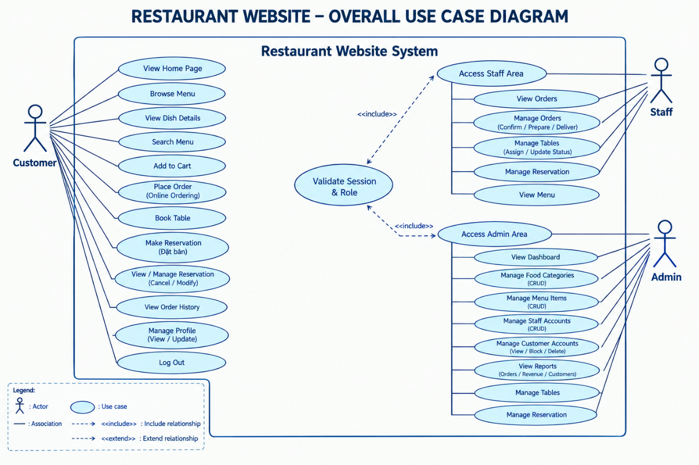
Figure 3-1 Use Case Diagram

Table 3-3 View Home Page
Use Case ID | UC01
Use Case Name | View Home Page
Description | The visitor opens the website and views the restaurant’s landing page. The page provides an entry point to public information and available customer-facing functions, including navigation to the menu and account pages.
Actor | Guest, Customer
Pre-conditions | The website is reachable in a supported browser.
Basic Flow of Events | 1. The actor navigates to the website’s home URL.  2. The system processes the home-page request and loads the home-page view.  3. The system retrieves the public content needed by the page, including available categories, selected available dishes, and current promotion or combo information when present.  4. The system renders the page and its navigation links.  5. The actor chooses a next action, such as browsing the menu, viewing restaurant information, registering, or logging in.
Post-conditions | The home page is displayed. This use case is read-only and does not create or modify business records.
Alternative / Exception Flows | • If optional promotion, combo, or dish data is unavailable, the page should still render the remaining content supported by the view.  • If the page cannot be loaded because of a server or database error, the system displays its configured error response.
Table 3-4 Browse Menu
Use Case ID | UC02
Use Case Name | Browse Menu
Description | The actor explores the restaurant menu. The system lists dishes currently marked as available and can narrow the list by category or a search term. Active combos may also be shown alongside dishes.
Actor | Guest, Customer, Staff
Pre-conditions | The website is available and menu data can be queried.
Basic Flow of Events | 1. The actor opens the menu page.  2. The system loads active categories and queries dishes whose status is Available.  3. If the actor selects a category, the system limits the dish list to that category.  4. If the actor enters a search term, the system searches dish names and descriptions; the menu page also filters combo names and descriptions where applicable.  5. The system orders and displays the matching results.  6. The actor reviews the results and may open a dish or combo detail view.
Post-conditions | The menu results matching the selected category and search term are displayed. No menu data is changed.
Alternative / Exception Flows | • If no items match the selected filters, the page displays an empty or no-results state according to the view.  • Items not marked Available are excluded from the dish listing.

Table 3-5 View Dish Details
Use Case ID | UC03
Use Case Name | View Dish Details
Description | The actor opens an individual dish to inspect its information before deciding whether to order it. The detail view can show the dish name, description, price, category, and associated images when those fields are available.
Actor | Guest, Customer
Pre-conditions | A dish identifier is supplied and the corresponding dish record exists.
Basic Flow of Events | 1. The actor selects a dish from the menu.  2. The system receives the selected dish identifier.  3. The system queries the dish and its related category and image records.  4. The system returns the dish detail view with the information available in the database.  5. The actor reviews the information and returns to the menu or continues to an ordering action if available.
Post-conditions | The selected dish information is displayed without changing the dish record.
Alternative / Exception Flows | • If no identifier is supplied or the dish cannot be found, the system returns a not-found response rather than displaying unrelated details.  • Availability for ordering is checked again when an item is added to the cart; viewing details alone does not reserve stock or a dish.
Table 3-6 Register Customer Account
Use Case ID | UC04
Use Case Name | Register Customer Account
Description | A new visitor creates a customer account by submitting the registration form. The system validates the submitted information and creates a customer identity only when the required data satisfies the application’s validation rules.
Actor | Guest
Pre-conditions | The visitor is not logged in and can access the registration page.
Basic Flow of Events | 1. The guest opens the registration page.  2. The guest enters the fields requested by the form and submits it.  3. The system validates required values and any configured format or password rules.  4. The system checks whether identifying information that must be unique is already in use.  5. If validation succeeds, the system creates a customer account and saves it to the database.  6. The system provides a success response and follows the application’s configured post-registration navigation.
Post-conditions | A customer account exists if the submitted data is valid and accepted. Registration does not imply that an existing account has been modified.
Alternative / Exception Flows | • If required data is missing, invalid, or duplicated, the system returns the form with validation feedback and does not create the account.  • If saving fails, the system must not report successful registration.
Table 3-7 Log In
Use Case ID | UC05
Use Case Name | Log In
Description | An existing user authenticates with account credentials and obtains a session associated with the user’s role. The role determines the protected functions and destination available after authentication.
Actor | Customer, Staff, Admin
Pre-conditions | The actor has an existing account and is not currently using an authenticated session.
Basic Flow of Events | 1. The actor opens the login page.  2. The actor enters the requested login credentials and submits the form.  3. The system validates the submitted values and looks up the corresponding account.  4. The system verifies the credential using the project’s authentication and password-hashing logic and checks whether the account is active.  5. When authentication succeeds, the system stores the required user identity and role information in the session.  6. The system redirects the actor to the appropriate destination or to the originally requested page when a valid return destination is supplied.
Post-conditions | A valid authenticated session is established after successful login. Failed authentication leaves the actor unauthenticated.
Alternative / Exception Flows | • If the credentials are incorrect, the account is inactive, or validation fails, the system shows an appropriate error and does not establish an authenticated session.  • A user must not gain access to a protected role area merely by entering its URL; authorization must also validate the session and role.
Table 3-8 Log Out
Use Case ID | UC06
Use Case Name | Log Out
Description | The actor ends the current authenticated session. This prevents the session from continuing to authorize requests to protected customer, staff, or administrator functions.
Actor | Customer, Staff, Admin
Pre-conditions | The actor has an active authenticated session.
Basic Flow of Events | 1. The actor selects the Log Out command.  2. The system clears or abandons the current session data used for authentication.  3. The system redirects the actor to a public page or the login page.  4. If the actor subsequently requests a protected page, the system checks the session again and requires authentication when the previous session is no longer valid.
Post-conditions | The previous authenticated session is ended and its session-based permissions are no longer available.
Alternative / Exception Flows | • If a protected page is requested after logout, the request is redirected to login or denied according to the configured authorization behavior.
Table 3-9 Manage Customer Profile
Use Case ID | UC07
Use Case Name | Manage Customer Profile
Description | An authenticated customer views and updates the personal profile associated with their own account. The system validates editable values before saving them and must not allow the customer to edit another user’s profile through a changed identifier.
Actor | Customer
Pre-conditions | The actor is logged in with the Customer role.
Basic Flow of Events | 1. The customer opens the profile page.  2. The system identifies the account from the current session and loads its profile information.  3. The customer edits the fields the interface permits them to change.  4. The customer submits the changes.  5. The system validates the submitted values and checks that the operation applies to the current customer account.  6. If valid, the system saves the changes and returns a confirmation to the customer.
Post-conditions | The customer’s profile is updated only when the submitted data is valid.
Alternative / Exception Flows | • If validation fails, the system redisplays the form with field-level feedback and does not save invalid changes.  • Unauthenticated requests must be redirected to login or denied.
Table 3-10 Change Password
Use Case ID | UC08
Use Case Name | Change Password
Description | An authenticated customer changes the password for their own account. The operation is intended to update authentication credentials without exposing the stored password representation.
Actor | Customer
Pre-conditions | The customer is logged in and can access the change-password page.
Basic Flow of Events | 1. The customer opens Change Password.  2. The customer enters the current password and the new password information requested by the form.  3. The system validates the submitted values and verifies the current credential according to the project’s password-handling logic.  4. The system checks the new password against the application’s validation rules.  5. If the checks pass, the system stores the new password using the project’s password-hashing mechanism.  6. The system reports the result to the customer.
Post-conditions | The account uses the new password after a successful change; profile and order records are not otherwise changed.
Alternative / Exception Flows | • If the current password is incorrect or the new password fails validation, the system rejects the change and displays feedback.  • Password values must not be displayed back as plain text or stored as plain-text credentials.
Table 3-11 Add Menu Items to Cart
Use Case ID | UC09
Use Case Name | Add Menu Items to Cart
Description | The customer adds an available dish or active combo to a session-based cart. The cart tracks item quantities so the customer can review selections before checkout; adding an item is not itself an order submission.
Actor | Customer
Pre-conditions | The customer is authenticated, and the selected dish or combo exists and is eligible for ordering.
Basic Flow of Events | 1. The customer selects a dish or combo and submits an add-to-cart action with a quantity.  2. The system checks the session for an authenticated user; if no user is logged in, it redirects to login.  3. The system normalizes the requested quantity to the supported range.  4. The system verifies that the selected dish is available, or that the selected combo can be added under the project’s combo rules.  5. The system adds the item to the cart or increments the existing quantity, applying the cart quantity limit.  6. The system saves the updated cart in the session and displays a success or error message.
Post-conditions | The session cart contains the accepted item and quantity. No order record is created until the checkout/order flow is completed.
Alternative / Exception Flows | • If an item is unavailable or invalid, the system informs the customer and does not add that item.  • Unauthenticated customers are directed to login before using the cart action.
Table 3-12 Review and Update Cart
Use Case ID | UC10
Use Case Name | Review and Update Cart
Description | The customer reviews the items currently held in the session cart and adjusts quantities or removes selections before checkout. The cart view helps the customer confirm the intended contents before submitting an order.
Actor | Customer
Pre-conditions | The customer is logged in and has opened the cart page.
Basic Flow of Events | 1. The customer opens the cart.  2. The system reads the cart contents from the current session and resolves the relevant dish or combo information.  3. The system displays item names, quantities, prices, and the calculated subtotal where supported by the page.  4. The customer changes quantities or removes items using the available controls.  5. The system validates the requested changes, updates the session cart, and recalculates displayed totals.  6. The customer proceeds to checkout when satisfied with the cart.
Post-conditions | The cart reflects the latest accepted changes and is ready for checkout. No order is created solely by viewing the cart.
Alternative / Exception Flows | • Invalid quantities are normalized or rejected according to the cart action’s validation rules.  • If a selected item is no longer eligible, the customer must be informed and the cart should not silently submit an invalid item.
Table 3-13 Place Order / Checkout
Use Case ID | UC11
Use Case Name | Place Order / Checkout
Description | The customer submits the cart as an order through checkout. The system validates the customer’s cart and checkout data, then records an order and its line items according to the supported order flow.
Actor | Customer
Pre-conditions | The customer is authenticated, the cart contains at least one eligible item, and the checkout page is available.
Basic Flow of Events | 1. The customer opens checkout from the cart.  2. The system loads the current cart and the checkout fields provided by the application.  3. The customer reviews the order contents and enters or confirms the requested checkout information.  4. The system validates required data, item eligibility, quantities, and the order totals using current item information.  5. If a promotion is supplied or supported by the checkout flow, the system validates its eligibility before applying it.  6. The system creates the order and associated order-item records using the accepted cart contents.  7. The system returns an order success result and directs the customer to the confirmation or receipt page.
Post-conditions | A valid order is persisted and the customer receives a confirmation view. Exact payment processing behavior depends on the payment functionality configured in the project.
Alternative / Exception Flows | • If checkout validation fails, the system returns feedback and must not create a successful order from invalid input.  • If an item becomes unavailable or data saving fails, the system reports the problem and allows the customer to review the cart again.
Table 3-14 View Order Confirmation / Receipt
Use Case ID | UC12
Use Case Name | View Order Confirmation / Receipt
Description | After a successful order submission, the customer views the result page or receipt associated with that order. The page provides confirmation details available from the saved order data.
Actor | Customer
Pre-conditions | An order has been successfully created and the customer has navigated to the corresponding result or receipt page.
Basic Flow of Events | 1. The customer reaches the order success or receipt page.  2. The system identifies the order using the supported route or session context.  3. The system loads the order and associated line-item information available to the view.  4. The system renders the confirmation or receipt information.  5. The customer reviews the result and may navigate to their order history.
Post-conditions | The customer can view the order result. This use case does not itself change order status or create a second order.
Alternative / Exception Flows | • If the order cannot be identified or found, the system displays an error or not-found response rather than a fabricated receipt.
Table 3-15 View My Orders
Use Case ID | UC13
Use Case Name | View My Orders
Description | The customer views their own order history to review orders previously placed and their current statuses. The list is scoped to the authenticated customer so that another customer’s orders are not exposed.
Actor | Customer
Pre-conditions | The actor is logged in with the Customer role.
Basic Flow of Events | 1. The customer opens My Orders.  2. The system identifies the customer from the authenticated session.  3. The system queries orders belonging to that customer.  4. The system displays the available order information, such as order identifiers, dates, totals, and statuses where those fields are included in the view.  5. The customer reviews the history and opens additional details if the interface provides them.
Post-conditions | The customer’s order history is displayed without changing any order.
Alternative / Exception Flows | • If the customer has no orders, the page displays an empty state.  • Unauthenticated requests are redirected to login or denied.
Table 3-16 Book a Table
Use Case ID | UC14
Use Case Name | Book a Table
Description | The customer submits a table reservation request for a future date and time by selecting an available table and entering any supported special request. The system validates the time and checks for conflicts before saving the request.
Actor | Customer
Pre-conditions | The customer is logged in, reservation data is available, and at least one active table is available for selection.
Basic Flow of Events | 1. The customer opens the reservation page.  2. The system loads reservation choices and tables that are active and have Available status.  3. The customer selects a table, a future reservation date and time, and optionally enters a special request.  4. The system derives the party size from the selected table’s capacity and associates the request with the authenticated customer.  5. The system validates the table, date/time, and special-request length.  6. The system checks whether the selected table has a conflicting reservation at the requested time, using the project’s conflict-validation and transaction logic.  7. If all checks pass, the system saves a reservation with its initial Pending status and displays the result.
Post-conditions | A valid reservation request is saved with Pending status. Submission does not imply that the reservation has already been confirmed by staff.
Alternative / Exception Flows | • A table that is inactive, not Available, or already reserved for a conflicting time cannot be selected successfully.  • A reservation time in the past or a special request exceeding the configured limit is rejected with validation feedback.
Table 3-17 View My Reservations
Use Case ID | UC15
Use Case Name | View My Reservations
Description | The customer reviews their own table-reservation requests and their saved statuses. The use case is read-only and lets the customer track whether a request is pending or has been processed.
Actor | Customer
Pre-conditions | The customer is logged in with the Customer role.
Basic Flow of Events | 1. The customer opens My Reservations.  2. The system obtains the customer identity from the current session.  3. The system retrieves reservation records associated with that customer.  4. The system displays the reservation date and time, selected table, party size, special request, and status where supported by the view.  5. The customer reviews the displayed reservation information.
Post-conditions | The customer’s reservation history is displayed without changing reservation records.
Alternative / Exception Flows | • If no reservations are associated with the customer, the page displays an empty state.  • The system must not return reservation records belonging to other customers.
Table 3-18 View My Reviews
Use Case ID | UC16
Use Case Name | View My Reviews
Description | The customer opens the review area to view review records associated with their account. This use case covers viewing the customer’s review history and does not assume review creation or editing behavior beyond the controls implemented in the project.
Actor | Customer
Pre-conditions | The customer is authenticated and the review page is available.
Basic Flow of Events | 1. The customer opens My Reviews.  2. The system identifies the customer from the current session.  3. The system queries review records associated with that customer.  4. The system displays the available review content and related item or order information where supported.  5. The customer reads the displayed reviews.
Post-conditions | The customer’s review information is displayed without modifying it.
Alternative / Exception Flows | • If no review records exist, the page displays an empty state.  • Requests must be scoped to the current customer account.
Table 3-19 View Orders
Use Case ID | UC17
Use Case Name | View Orders (Staff/Admin)
Description | An authorized staff member or administrator views the order list to monitor order activity. The list reflects saved order data and current statuses, and provides an entry point to inspect individual orders when the detail view is available.
Actor | Staff, Admin
Pre-conditions | The actor is authenticated and has permission to view orders.
Basic Flow of Events | 1. The actor opens the order-management list.  2. The system verifies the session and role permissions.  3. The system queries order records within the permitted scope and applies any supported filters or sorting.  4. The system displays the order list with the available customer, date, total, and status information.  5. The actor selects an order to inspect its details when supported.
Post-conditions | The order list is displayed. Merely viewing an order does not alter its status or contents.
Alternative / Exception Flows | • If the actor lacks permission, the system denies access or redirects to an authorized page.  • If no orders match the current filters, the system displays an empty result.

Table 3-20 Manage Orders and Update Status
Use Case ID | UC18
Use Case Name | Manage Orders and Update Status
Description | An authorized actor inspects an order and performs supported order-management actions, including changing the order status where that action is available. The system validates permissions and persists only accepted changes.
Actor | Staff, Admin
Pre-conditions | The actor is authenticated with permission to manage orders, and the selected order exists.
Basic Flow of Events | 1. The actor opens the order-management area and selects an order.  2. The system loads and displays the order and its line-item details.  3. The actor chooses an available management action or a new status from the options shown by the interface.  4. The system validates the requested value and confirms that the actor has permission to perform the action.  5. The system saves the accepted update to the order record.  6. The system displays a success message and refreshes the visible order information.
Post-conditions | The order is updated only when the requested operation is permitted and valid.
Alternative / Exception Flows | • If the order does not exist, the system returns an error or not-found response.  • Invalid status values or unauthorized changes are rejected and the saved order remains unchanged.
Table 3-21 View Menu in Staff Area
Use Case ID | UC19
Use Case Name | View Menu in Staff Area
Description | A staff member views menu information for operational reference. This use case is limited to viewing dishes and does not grant permission to edit menu data unless a separate administrative permission is provided.
Actor | Staff
Pre-conditions | The staff member is authenticated and authorized to use the staff menu page.
Basic Flow of Events | 1. The staff member opens the staff menu view.  2. The system checks the authenticated session and staff role.  3. The system retrieves the menu data needed by the page.  4. The system displays the available dish information.  5. The staff member reviews the information for service or order-handling purposes.
Post-conditions | The staff menu is displayed without modifying dishes or categories.
Alternative / Exception Flows | • If the actor lacks the Staff role, the system denies access.  • Editing menu records remains outside this use case unless explicitly exposed through a separately authorized function.
Table 3-22 Manage Reservations
Use Case ID | UC20
Use Case Name | Manage Reservations
Description | An authorized staff member or administrator reviews reservation requests and processes supported actions, such as confirming or cancelling a request or updating its status. The system checks the reservation and any related table constraints before saving changes.
Actor | Staff, Admin
Pre-conditions | The actor is authenticated and has permission to manage reservations; the reservation record exists.
Basic Flow of Events | 1. The actor opens the reservation-management list.  2. The system loads reservations and displays their current status and relevant booking details.  3. The actor filters the list or opens a reservation’s details.  4. The actor selects a supported action, such as confirming, completing, or cancelling the reservation.  5. The system validates the requested status transition and checks related table information when required.  6. The system saves the change and presents the updated status.
Post-conditions | The reservation record reflects the accepted operation.
Alternative / Exception Flows | • If a reservation or related table cannot be found, the system rejects the operation and provides feedback.  • The system must apply the project’s conflict rules when an operation assigns or changes a table so overlapping bookings are not silently accepted.
Table 3-23 Manage Restaurant Tables
Use Case ID | UC21
Use Case Name | Manage Restaurant Tables
Description | An authorized actor maintains restaurant table records used by the reservation workflow. Depending on the available interface, the actor can view the table list, create a table, edit its properties, or change supported status information.
Actor | Staff, Admin
Pre-conditions | The actor is authenticated and has permission to manage tables.
Basic Flow of Events | 1. The actor opens the table-management page.  2. The system lists the existing restaurant tables and their saved properties or statuses.  3. The actor creates a new table or selects an existing table for editing.  4. The actor enters or updates supported fields, such as the table label, capacity, or active/status information.  5. The system validates required values and checks relevant reservation relationships.  6. If valid, the system saves the new or updated table and displays the result.
Post-conditions | The table list reflects the saved change when validation succeeds.
Alternative / Exception Flows | • Invalid table information is rejected with validation feedback.  • A table that is referenced by existing reservations must not be deleted or changed in a way that violates the application’s relationship or booking rules.
Table 3-24 View Admin Dashboard
Use Case ID | UC22
Use Case Name | View Admin Dashboard
Description | The administrator views a consolidated overview of restaurant website activity using the dashboard elements implemented in the project. The displayed values are based on the queries and widgets available in the current version.
Actor | Admin
Pre-conditions | The actor is authenticated with the Admin role and the dashboard page is available.
Basic Flow of Events | 1. The administrator opens the dashboard.  2. The system verifies the session and Admin role.  3. The system queries or aggregates the data required by the dashboard widgets.  4. The system renders the available counts, summaries, or visual indicators.  5. The administrator reviews the overview and navigates to a management section if needed.
Post-conditions | The dashboard displays the information currently supported by the application. Viewing the dashboard does not modify business records.
Alternative / Exception Flows | • If a data source is unavailable, the system follows the page’s configured error handling rather than inventing figures.  • Users without Admin authorization are denied access.
Table 3-25 Manage Food Categories
Use Case ID | UC23
Use Case Name | Manage Food Categories
Description | The administrator maintains the categories used to organize dishes on the menu. The category-management interface supports viewing the category list and the create/edit operations exposed by the project.
Actor | Admin
Pre-conditions | The administrator is authenticated and authorized, and the category-management module is available.
Basic Flow of Events | 1. The administrator opens the category list.  2. The system displays the saved categories and their available properties.  3. The administrator starts a create operation or selects an existing category to edit.  4. The administrator enters or updates the category information requested by the form.  5. The system validates required fields and checks constraints related to dishes that reference the category.  6. The system saves the valid category changes and returns to the list with a result message.
Post-conditions | A category is created or updated if the submitted information passes validation.
Alternative / Exception Flows | • If the form data is invalid, the system redisplays validation feedback without saving the invalid values.  • Deleting or changing a category must respect the relationships to existing dishes and the operations actually supported by the interface.
Table 3-26 Manage Menu Items
Use Case ID | UC24
Use Case Name | Manage Menu Items
Description | The administrator maintains dish records displayed on the public menu. The management workflow includes viewing the list and creating or editing dish information exposed by the administrative interface, including category, price, description, images, and status where available.
Actor | Admin
Pre-conditions | The administrator is authenticated and authorized, and the dish-management module is available.
Basic Flow of Events | 1. The administrator opens the dish list.  2. The system retrieves dishes and related category or image information needed by the page.  3. The administrator creates a new dish or selects an existing dish for editing.  4. The administrator enters or updates the fields offered by the form, such as name, category, description, price, image, and status.  5. The system validates required fields, numeric values, and related category data.  6. The system saves the accepted dish changes and displays a success result.
Post-conditions | The dish record and related supported information are created or updated after successful validation.
Alternative / Exception Flows | • Invalid or incomplete data is rejected and the form displays validation messages.  • A dish’s status affects whether it appears in the public menu; only dishes marked Available are included in the menu listing.
Table 3-27 Manage User and Staff Accounts
Use Case ID | UC25
Use Case Name | Manage User and Staff Accounts
Description | The administrator views user accounts and performs the account-management operations exposed by the project, including creating staff accounts and viewing account details. This function is separate from customer self-registration.
Actor | Admin
Pre-conditions | The administrator is authenticated and authorized to manage accounts.
Basic Flow of Events | 1. The administrator opens the user-management list.  2. The system displays account information within the scope of the management view.  3. The administrator chooses an available operation, such as opening account details or creating a staff account.  4. For staff creation, the administrator enters the requested account information and role-related values.  5. The system validates the data and checks the permissions and constraints applicable to the operation.  6. The system saves the accepted account operation and reports the result.
Post-conditions | A staff account is created or account information is viewed/updated only when the selected operation is supported and valid.
Alternative / Exception Flows | • Invalid account information is rejected with feedback.  • The interface must not expose plain-text credentials, and privileged roles must not be assigned unintentionally.
Table 3-28 Manage Promotions
Use Case ID | UC26
Use Case Name | Manage Promotions
Description | The administrator creates and maintains promotion definitions that can be displayed or considered during the ordering flow. The management page supports listing, searching, filtering by discount type or status, and the create/edit operations exposed by the project.
Actor | Admin
Pre-conditions | The administrator is authenticated and authorized to manage promotions.
Basic Flow of Events | 1. The administrator opens the promotions page.  2. The system displays promotion records and supports the available search and filter fields.  3. The administrator creates a new promotion or selects an existing promotion for editing.  4. The administrator supplies the code, name, description, discount type and value, validity dates, minimum order amount, and other supported limits.  5. The system validates required values, uniqueness of the promotion code, positive discount values, percentage limits, date order, and any configured usage constraints.  6. If the data is valid, the system saves the promotion and displays a success message.
Post-conditions | The promotion is created or updated when all applicable validations pass.
Alternative / Exception Flows | • A duplicate code, invalid discount value, negative threshold, invalid date range, or invalid usage limit is rejected.  • The existence of a promotion does not by itself mean it will be automatically applied to every order; application depends on the checkout logic and eligibility rules.

Entity Relationship Diagram (ERD)
The Entity Relationship Diagram (ERD) illustrates the logical structure of the database designed for the Restaurant Website system. It identifies the major entities, their attributes, primary keys, foreign keys, and the relationships established among them. The ERD provides a foundation for database implementation by defining how restaurant information, menu items, customer accounts, orders, payments, table reservations, reviews, and promotional activities are organized and connected.
The database is designed to support the main business processes of the restaurant website, including menu browsing, dish and combo management, customer account management, online ordering, payment processing, table reservations, customer reviews, and promotion management. Each entity represents a database table responsible for storing a specific category of information. Relationships between entities are established through primary keys and foreign keys to maintain referential integrity and support efficient data retrieval.

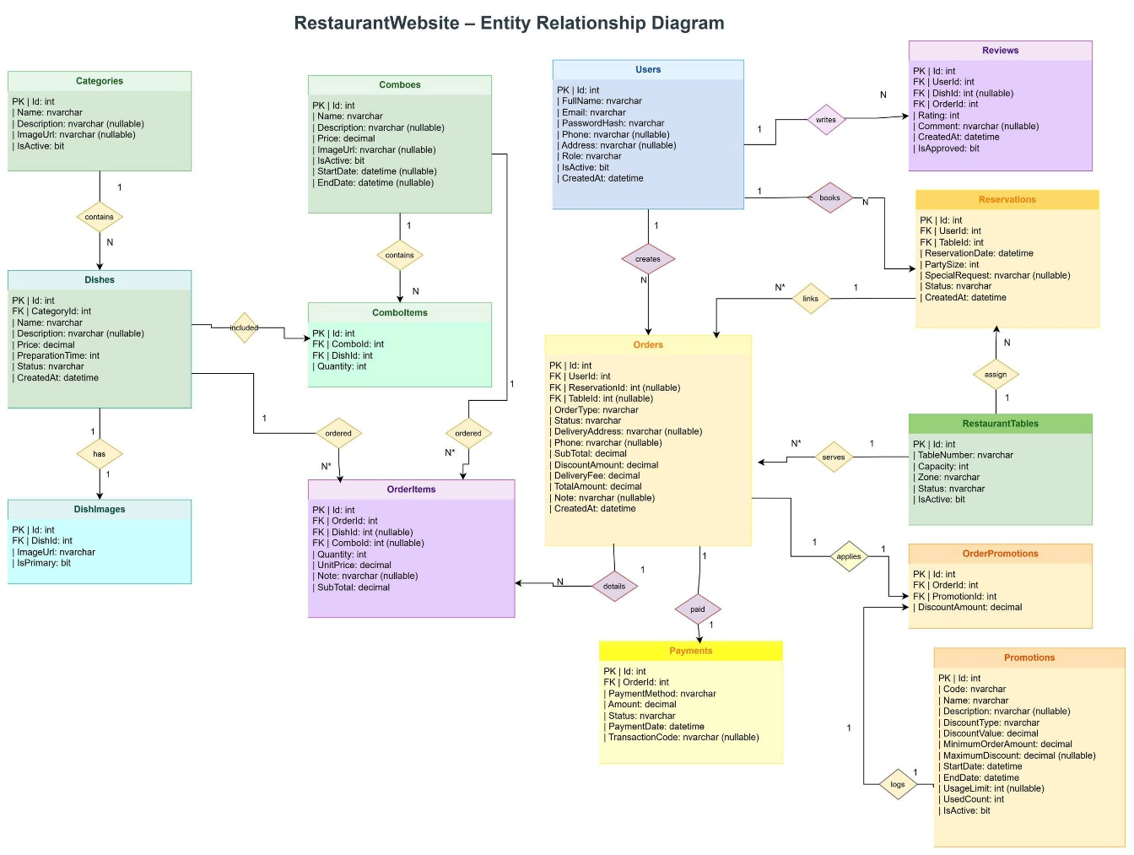
Figure 3-2 Entity Relationship Diagram
As illustrated in Figure 3.1, the database consists of several interconnected groups of entities. The first group manages restaurant menu information, including Categories, Dishes, DishImages, Combos, and ComboItems. The second group supports customer accounts and restaurant transactions through Users, Orders, OrderItems, and Payments. The remaining entities, including Reviews, Reservations, RestaurantTables, Promotions, and OrderPromotions, provide additional functionality for customer feedback, table booking, and promotional campaigns.
The Categories entity stores information about the different categories available on the restaurant menu. Its attributes include the category identifier, name, description, image URL, and active status. This entity allows dishes to be classified into appropriate groups, making the menu easier to organize and browse. A one-to-many relationship exists between Categories and Dishes because one category can contain multiple dishes, while each dish belongs to a category.
The Dishes entity stores detailed information about individual food items offered by the restaurant. Its attributes include the dish identifier, category identifier, name, description, price, image URL, preparation time, status, and creation date. The category identifier connects each dish to its corresponding category. This relationship enables the system to retrieve dishes by category and maintain consistent menu information. The dish status also supports the management of food availability within the restaurant website.
The DishImages entity is responsible for storing image information associated with individual dishes. It includes an image identifier, dish identifier, image URL, and a flag indicating whether an image is the primary image. A dish can have multiple associated images, while each image record belongs to a specific dish. This one-to-many relationship allows the website to display multiple images for a food item and distinguish its primary image from additional images.
The Combos entity stores information about food combinations offered by the restaurant. Its attributes include the combo identifier, name, description, price, image URL, active status, start date, and end date. This entity allows the restaurant to introduce predefined meal combinations and manage their availability over a specified period. The ComboItems entity connects Combos with Dishes and stores the quantity of each dish included in a combo. Because one combo may contain multiple dishes and one dish may appear in multiple combos, ComboItems acts as an associative entity that represents the many-to-many relationship between Combos and Dishes. Its composite primary key consists of the combo identifier and dish identifier, ensuring that each dish entry within a combo can be uniquely identified.
The Users entity stores account and profile information for people who interact with the restaurant website. Its attributes include the user identifier, full name, email, password hash, phone number, address, role, active status, and account creation date. The entity supports user authentication, account management, and role-based access to system functions. The role attribute distinguishes the types of users supported by the application, while the active status indicates whether an account is currently enabled. User information is associated with several business activities, including placing orders, making reservations, and submitting reviews.
The Orders entity records the main information associated with customer orders. Its attributes include the order identifier, user identifier, reservation reference where applicable, table identifier where applicable, order date, order status, subtotal, tax amount, discount amount, total amount, and creation date, as represented in the ERD. Each order is associated with a user, while its reservation and table references support the connection between ordering activities and restaurant table arrangements where applicable. The monetary attributes provide a structured record of the order value and its related charges and discounts. The order status represents the current stage of the transaction and supports order processing and tracking.
The OrderItems entity stores the individual items included in each order. It connects an order with the dishes or combos selected by the customer and records item-level information, such as quantity and unit price, according to the database structure. An order can contain multiple order items, while each order item belongs to a particular order. This one-to-many relationship separates general order information from the details of individual products. It also enables the system to determine which dishes or combos were ordered, calculate item-level amounts, and retrieve the complete contents of an order.
The Payments entity stores payment information associated with customer orders. Its attributes include the payment identifier, order identifier, payment method, amount, status, transaction date, and transaction code where applicable. Each payment record is associated with an order through the order identifier. This relationship allows the system to maintain payment information separately from the order itself, making it easier to track payment amounts, transaction references, and payment statuses. Separating payment records from order records also helps organize financial information without duplicating general order details.
The Reviews entity stores customer feedback concerning the restaurant website's services or offerings. Its attributes include the review identifier, user identifier, dish identifier where applicable, rating, comment, review date, and approval status. The user identifier connects each review to the person who submitted it, while the dish identifier associates the review with the relevant dish when a dish-specific review is recorded. A user may submit multiple reviews, and a dish may receive reviews from multiple users. These relationships allow the system to retrieve customer feedback and organize reviews according to their authors and associated dishes. The approval status provides a field for managing the publication state of reviews.
The Reservations entity manages customer requests to reserve restaurant tables. Its attributes include the reservation identifier, user identifier, table identifier, reservation date and time, party size, reservation status, and creation date. Each reservation is associated with a user and a restaurant table through the corresponding identifiers. The user relationship allows the system to retrieve reservations belonging to a particular customer, while the table relationship identifies the table associated with a reservation. A restaurant table can be referenced by multiple reservation records over time, provided that their schedules and statuses satisfy the restaurant's booking rules. The reservation date, party size, and status support the organization and monitoring of table bookings.
The RestaurantTables entity stores information about the physical tables available at the restaurant. Its attributes include the table identifier, table name or number, capacity, status, and active status. The capacity attribute indicates the number of customers a table can accommodate, while the status describes its current operational or availability state. This entity is connected to Reservations and Orders through their respective table references, allowing the system to associate table information with booking and ordering activities. By maintaining table information separately, the system can organize restaurant seating and retrieve the relevant table details when processing reservations or orders.
The Promotions entity stores information about promotional campaigns and discount programs offered by the restaurant. Its attributes include the promotion identifier, code, name, description, discount type, discount value, minimum order amount, maximum discount amount where applicable, start date, end date, usage limit, used count, and active status. These attributes allow the restaurant to define promotion codes, specify discount conditions, control promotional validity periods, and monitor usage. The active status indicates whether a promotion is enabled, while the validity dates and usage-related attributes support the management of promotional availability.
The OrderPromotions entity connects Orders and Promotions and records the association between an order and a promotion applied to it. Its attributes include the identifier of the association record, order identifier, and promotion identifier. This entity represents the many-to-many relationship between Orders and Promotions: an order may be associated with a promotion, and a promotion may be used by multiple orders, subject to the promotion's rules and usage limits. By maintaining this association in a separate table, the database can track promotional usage and identify which orders were associated with specific campaigns without storing repeated promotion information in every order record.
The relationships among these entities form an integrated data structure for restaurant operations. Categories organize Dishes, while DishImages stores additional image records for individual dishes. Combos and Dishes are connected through ComboItems, which defines the composition of each combo. Users are associated with Orders, Reservations, and Reviews, enabling the system to maintain customer-related transaction and feedback information. Orders are connected to OrderItems and Payments to support order-detail management and payment tracking. RestaurantTables is associated with Reservations and may also be referenced by Orders, while OrderPromotions connects orders to promotional campaigns.
Overall, the Entity Relationship Diagram provides a structured representation of the restaurant website's database and the relationships among its major business entities. By separating menu information, customer accounts, order records, payment transactions, reservations, reviews, and promotional data into dedicated entities, the design supports organized data storage and retrieval. Primary keys and foreign keys establish the connections between related records and help maintain referential integrity. The ERD therefore serves as an important foundation for implementing the database and supporting the restaurant website's core business operations.

IMPLEMENTATION AND TESTING
This chapter presents the implementation and manual testing of the Restaurant and Food Order Management System. It describes the application setup, main user workflows and test cases for customers, staff and administrators. The demonstration section explains the screens to capture for the final report.

Implementation Environment and Application Setup
The application uses C#, ASP.NET MVC 5 and .NET Framework 4.8. Entity Framework 6.5.2 connects the application to Microsoft SQL Server. Razor Views, HTML, CSS, Bootstrap, JavaScript and jQuery are used for the interface. The local development environment uses Visual Studio with the ASP.NET workload, the .NET Framework 4.8 Developer Pack and IIS Express.
Table 4-1 Testing Environment
Item | Description
Application | RestaurantWebsite
Source repository | https://github.com/chipcao1/RestaurantWebsite/tree/Yamy
Programming language | C#
Framework | ASP.NET MVC 5 / .NET Framework 4.8
Data access | Entity Framework 6.5.2
Database | Microsoft SQL Server
Browser | Google Chrome on Windows
Test approach | Manual functional testing with Customer, Staff and Admin accounts.

Database Initialization and Sample Accounts
Open RestaurantWebsite.slnx in a compatible Visual Studio version, restore NuGet packages and set RestaurantWebsite as the startup project. Update the Data Source in Web.config to the SQL Server instance on the test computer. Build the application and run Update-Database in Package Manager Console with RestaurantWebsite selected as the default project.
Update-Database applies the original main-branch schema and automatically runs the seed embedded in the application assembly. Seed.sql inserts missing demonstration records, while UpdateFoodImages.sql replaces recognized legacy sample-image URLs. Re-running the command preserves existing passwords, edited prices and other existing record values; sample insertion relies on the documented record identifiers. No additional migration is required.
Alternatively, execute the root DATABASE.sql in SQL Server Management Studio. It creates RestaurantWebsite when necessary, applies the InitialCreate schema, records the corresponding EF6 migration history and inserts the same sample data. The script does not drop existing tables or databases. A database containing tables but no compatible migration history requires separate inspection rather than being assumed compatible.
The demonstration accounts are admin.yamy@example.test (Admin), staff.yamy@example.test (Staff), and khach1.yamy@example.test / khach2.yamy@example.test (Customer). Their initial sample password is YamyDemo@2026!. Existing sample accounts retain their previous passwords. These credentials are for demonstration and testing only.

Implemented Structure and Role Workflows
The project retains the MVC 5 structure, with role-specific controllers and views under Areas/Customer, Areas/Staff and Areas/Admin. Shared services handle checkout quotations, promotions, table reservations and order-state changes. AppDbContext maps the existing relational schema, including dbo.Comboes. Custom authorization checks protect role-restricted actions and verify the current account rather than relying only on visible navigation links.
Visitors can browse the home-page preview and the full menu, filter categories and inspect dish details. The home page previews six matching results, while the menu provides the complete eligible catalogue. Ordering requires an active customer session; signed-out dish details do not expose quantity selection. Customers manage their carts, place orders, reserve tables and review their own order and reservation histories.
Login redirects each account to its designated role workspace. Staff process orders, record payment status, manage reservations and perform permitted catalogue operations; dish deletion is not exposed in the staff area. Administrators manage the catalogue, combos, promotions, reporting and accounts, and can switch between the administrator and staff workspaces while retaining the Admin role.
Administrator account management provides account viewing, password reset to 123456789, account locking/unlocking and staff-account creation. It does not provide unrestricted editing of another user’s profile. Passwords are handled by the application PasswordHasher with salted PBKDF2 for current hashes and compatibility handling for supported legacy hashes.

Business Validation and Interface Behaviour
Checkout recalculates item prices and quantities from database records. Entering a promotion code requests an immediate preview and updates the summary with the code, discount description and monetary reduction. Final submission validates the promotion again before recording its usage. Supported order types are dine-in, takeaway and delivery; delivery requires a valid contact address.
An operator moves an order through Pending, Confirmed, Preparing and Ready. Completion is stored as Delivered and is allowed only after payment has been recorded as Completed. Cash, bank transfer and digital-wallet values are recorded by the application; choosing one does not by itself prove settlement through an external payment gateway.
Reservations require a future service time, an active available table and sufficient capacity. The service checks overlapping two-hour reservations and relevant open orders. Dish photographs use external URLs selected by dish name. Default combos display photographs of their actual component dishes; custom HTTPS combo images are retained. Internet access is therefore required for external photographs, with a local placeholder used when loading fails.

Testing Method
Manual functional testing is used to check the main user workflows. The tester enters the specified data, performs the steps and compares the displayed result with the expected result. Each test case records the test data, precondition, steps, expected result, actual result and status.
Testing uses sample accounts for the Customer, Staff and Admin roles and the sample menu records. For this report draft, the results below assume that all 25 manual test cases have passed.

Testing Scenarios and Results
The following 25 manual test cases cover valid input, invalid input and access restrictions. Use the default sample accounts and a separate test database. A case is marked Pass when the result matches the expected behaviour, including rejection of invalid input.

Account Registration and Login
Table 4-2 TC01 - Successful Registration
Field | Details
Test case | TC01 - Successful Registration
Test data | Name: Test Customer; email: testing.customer@example.test; password and confirmation: Test@2026!.
Precondition | The visitor is signed out and the email has not been registered.
Steps | 1. Open registration. 2. Enter the test data. 3. Submit the form.
Expected result | A new active Customer account is created and the login page is displayed.
Actual result | The account was created and the login page was displayed.
Status | Pass
Table 4-3 TC02 - Registration with an Existing Email
Field | Details
Test case | TC02 - Registration with an Existing Email
Test data | Email: testing.customer@example.test; other fields contain valid data.
Precondition | The email was registered in TC01. The visitor is signed out.
Steps | 1. Open registration. 2. Enter the existing email and valid remaining fields. 3. Submit.
Expected result | Registration is rejected with an email validation message. No duplicate account is created.
Actual result | The form reported that the email was already registered. No duplicate account was created.
Status | Pass
Table 4-4 TC03 - Login with Valid Credentials
Field | Details
Test case | TC03 - Login with Valid Credentials
Test data | Email: testing.customer@example.test; password: Test@2026!.
Precondition | The account from TC01 is active. The browser is signed out.
Steps | 1. Open Login. 2. Enter the email and correct password. 3. Submit.
Expected result | Login succeeds and opens the customer home page.
Actual result | The customer logged in and the customer home page opened.
Status | Pass
Table 4-5 TC04 - Login with an Incorrect Password
Field | Details
Test case | TC04 - Login with an Incorrect Password
Test data | Email: testing.customer@example.test; password: Wrong@2026!.
Precondition | The account exists and the browser is signed out.
Steps | 1. Open Login. 2. Enter the email and incorrect password. 3. Submit.
Expected result | Login is rejected and a validation message is shown.
Actual result | Login was rejected. The visitor remained on the login page with a validation message.
Status | Pass

Browse Menu and View Food Details
Table 4-6 TC05 - Filter the Menu by Category
Field | Details
Test case | TC05 - Filter the Menu by Category
Test data | Category: Món chính.
Precondition | The category is active and contains available dishes.
Steps | 1. Open the full menu. 2. Select Món chính. 3. Check the displayed dishes.
Expected result | Only eligible dishes from Món chính are displayed.
Actual result | The menu showed the available dishes from Món chính and hid dishes from other categories.
Status | Pass
Table 4-7 TC06 - View Dish Details while Signed Out
Field | Details
Test case | TC06 - View Dish Details while Signed Out
Test data | Dish: Gà nướng thảo mộc; sample price: VND 99,000.
Precondition | The visitor is signed out. The dish is available and its image can be loaded.
Steps | 1. Open the menu. 2. Open the dish details. 3. Check the information and ordering controls.
Expected result | The matching image, description and price are shown. Quantity selection is hidden.
Actual result | The correct dish details and VND 99,000 price were shown. No quantity selector was displayed.
Status | Pass

Add Items to Cart and Update Quantity
Table 4-8 TC07 - Update Cart Quantity
Field | Details
Test case | TC07 - Update Cart Quantity
Test data | Dish: Gà nướng thảo mộc; unit price: VND 99,000; new quantity: 2.
Precondition | A customer is logged in and the cart contains one serving of the dish.
Steps | 1. Open the cart. 2. Change the quantity from 1 to 2. 3. Check the updated totals.
Expected result | The line subtotal and cart total become VND 198,000.
Actual result | The quantity changed to 2 and the subtotal and total became VND 198,000.
Status | Pass
Table 4-9 TC08 - Remove an Item from the Cart
Field | Details
Test case | TC08 - Remove an Item from the Cart
Test data | A cart containing only Gà nướng thảo mộc.
Precondition | The customer is logged in and the cart contains the test item.
Steps | 1. Open the cart. 2. Remove the item. 3. Check the cart contents and total.
Expected result | The item is removed and the cart displays its empty state.
Actual result | The item was removed. The cart was empty and its total was updated.
Status | Pass

Checkout and Create an Order
Table 4-10 TC09 - Place a Valid Takeaway Order
Field | Details
Test case | TC09 - Place a Valid Takeaway Order
Test data | Cart: 2 × Gà nướng thảo mộc; Takeaway; Cash; phone: 0901234567; no promotion.
Precondition | The customer is logged in. The dishes are available and the subtotal is VND 198,000.
Steps | 1. Open checkout. 2. Select Takeaway and Cash and enter the phone. 3. Submit. 4. Open order history.
Expected result | An order totalling VND 198,000 is saved as Pending and appears in order history.
Actual result | The order was saved with a VND 198,000 total and Pending status. It appeared in order history.
Status | Pass
Table 4-11 TC10 - Apply a Valid Promotion Code
Field | Details
Test case | TC10 - Apply a Valid Promotion Code
Test data | Subtotal: VND 198,000; promotion code: YM10.
Precondition | The customer is on checkout. YM10 is active, within its dates and usage limit, and eligible for the subtotal.
Steps | 1. Enter YM10. 2. Wait for the summary to update. 3. Check the code, discount and total.
Expected result | The summary shows YM10, a 10% discount of VND 19,800 and a total of VND 178,200.
Actual result | The summary immediately showed YM10, a VND 19,800 discount and a VND 178,200 total.
Status | Pass
Table 4-12 TC11 - Apply an Expired Promotion Code
Field | Details
Test case | TC11 - Apply an Expired Promotion Code
Test data | Promotion code: TESTEXP; end date: yesterday; other conditions valid.
Precondition | Create TESTEXP in the test database with its end date in the past. The customer has a valid cart.
Steps | 1. Open checkout. 2. Enter TESTEXP. 3. Review the message and order summary.
Expected result | The expired code is rejected. No discount is applied.
Actual result | The system rejected TESTEXP and kept the total unchanged.
Status | Pass
Table 4-13 TC12 - Submit Delivery without an Address
Field | Details
Test case | TC12 - Submit Delivery without an Address
Test data | Customer: testing.customer@example.test; Delivery; Cash; phone: 0901234567; empty delivery address.
Precondition | The customer has a valid cart and no address saved in their profile.
Steps | 1. Open checkout. 2. Select Delivery. 3. Leave the address empty and submit.
Expected result | Address validation prevents order creation and asks for a delivery address.
Actual result | The missing-address validation was displayed and no order was created.
Status | Pass

Create a Table Reservation
Table 4-14 TC13 - Create a Valid Table Reservation
Field | Details
Test case | TC13 - Create a Valid Table Reservation
Test data | Table: YM01; guests: 2; reservation: tomorrow at 18:00.
Precondition | A customer is logged in. YM01 is active, has two seats and is free during the service window.
Steps | 1. Open the reservation form. 2. Enter the test date, time, guests and table. 3. Submit and open reservation history.
Expected result | The reservation is saved as Pending and appears with the correct details.
Actual result | The reservation appeared in history with Pending status, YM01, two guests and the selected time.
Status | Pass
Table 4-15 TC14 - Book an Overlapping Table Time
Field | Details
Test case | TC14 - Book an Overlapping Table Time
Test data | Table: YM01; guests: 2; reservation: tomorrow at 18:30.
Precondition | YM01 already has the Pending reservation from TC13 at 18:00.
Steps | 1. Open the reservation form. 2. Select YM01 at 18:30 on the same date. 3. Submit.
Expected result | The overlapping reservation is rejected and no second booking is saved.
Actual result | The system reported a table/time conflict and did not save a second reservation.
Status | Pass
Table 4-16 TC15 - Book a Table with Insufficient Capacity
Field | Details
Test case | TC15 - Book a Table with Insufficient Capacity
Test data | Table: YM01; capacity: 2; guests: 3; a different available future time.
Precondition | The customer is logged in. YM01 is active and free at the test time.
Steps | 1. Open the reservation form. 2. Select YM01 and enter three guests. 3. Submit.
Expected result | The booking is rejected because the party exceeds the table capacity.
Actual result | Capacity validation rejected the booking and no reservation was created.
Status | Pass

Staff Order Processing
Table 4-17 TC16 - Confirm a Pending Order
Field | Details
Test case | TC16 - Confirm a Pending Order
Test data | Staff: staff.yamy@example.test; an order in Pending status.
Precondition | The staff account is logged in and the test order exists.
Steps | 1. Open order management. 2. Select the order. 3. Change Pending to Confirmed. 4. Save and refresh.
Expected result | The order status is saved as Confirmed and remains after refresh.
Actual result | The order was updated to Confirmed and retained that status after refresh.
Status | Pass
Table 4-18 TC17 - Complete an Unpaid Order
Field | Details
Test case | TC17 - Complete an Unpaid Order
Test data | An order in Ready status with a Pending payment.
Precondition | Staff is logged in. The order has followed the allowed processing sequence but payment is not completed.
Steps | 1. Open the order details. 2. Attempt to complete the order without recording payment.
Expected result | Completion is rejected and the order remains Ready.
Actual result | The system rejected completion and kept the order in Ready status.
Status | Pass
Table 4-19 TC18 - Complete a Paid Order
Field | Details
Test case | TC18 - Complete a Paid Order
Test data | An order in Ready status with its payment recorded as Completed.
Precondition | Staff is logged in. The order is ready and payment has been recorded.
Steps | 1. Open the order. 2. Complete the order. 3. Refresh the details.
Expected result | The order is saved as Delivered, displayed as completed in the interface.
Actual result | The order reached Delivered status and retained its completed state after refresh.
Status | Pass

Administration of Categories and Dishes
Table 4-20 TC19 - Create a Category
Field | Details
Test case | TC19 - Create a Category
Test data | Category name: Test Category; description: Test menu category; active: Yes.
Precondition | Admin is logged in and Test Category does not already exist.
Steps | 1. Open category management. 2. Create the category using the test data. 3. Save and check the list.
Expected result | The new active category is saved and listed.
Actual result | Test Category was saved and appeared in the category list as active.
Status | Pass
Table 4-21 TC20 - Create a Dish
Field | Details
Test case | TC20 - Create a Dish
Test data | Name: Test Dish; category: Test Category; price: VND 50,000; preparation: 15 minutes; status: Available.
Precondition | Admin is logged in. The category from TC19 exists and the dish name is unused.
Steps | 1. Open dish management. 2. Enter the test data in the creation form. 3. Save and check the list.
Expected result | The dish is saved with the selected category, price and status.
Actual result | Test Dish appeared in the list under Test Category with a VND 50,000 price and Available status.
Status | Pass
Table 4-22 TC21 - Create a Combo
Field | Details
Test case | TC21 - Create a Combo
Test data | Name: Test Combo; price: VND 90,000; component: 2 × Test Dish; active: Yes; valid dates.
Precondition | Admin is logged in. Test Dish from TC20 is available and its category is active.
Steps | 1. Open combo management and choose Create. 2. Enter the name, price and dates. 3. Select Test Dish with quantity 2. 4. Save.
Expected result | The combo is saved with the correct price and component quantity.
Actual result | Test Combo appeared in the combo list with a VND 90,000 price and two servings of Test Dish.
Status | Pass

Access Control by User Role
Table 4-23 TC22 - Open an Admin Page without Permission
Field | Details
Test case | TC22 - Open an Admin Page without Permission
Test data | Customer: khach1.yamy@example.test; Staff: staff.yamy@example.test; URL: /Admin/Users.
Precondition | Both accounts are active. Use separate signed-in sessions.
Steps | 1. Sign in as Customer and request /Admin/Users directly. 2. Repeat the request as Staff.
Expected result | Neither role can access the administrator user-management page.
Actual result | Both Customer and Staff were denied access to the Admin page.
Status | Pass
Table 4-24 TC23 - Switch Administrator Workspaces
Field | Details
Test case | TC23 - Switch Administrator Workspaces
Test data | Admin: admin.yamy@example.test.
Precondition | The administrator is logged in to the Admin workspace.
Steps | 1. Use navigation to open the Staff workspace. 2. Return to the Admin workspace.
Expected result | Both workspaces open without changing the account’s Admin role.
Actual result | The administrator opened both workspaces successfully and retained the Admin role.
Status | Pass
Table 4-25 TC24 - Reset an Account Password
Field | Details
Test case | TC24 - Reset an Account Password
Test data | Target: staff.reset@example.test; reset password: 123456789.
Precondition | Admin is logged in. An active disposable Staff account named staff.reset@example.test has been prepared.
Steps | 1. Open user management. 2. Reset the target account’s password. 3. Sign out and log in as the target with 123456789.
Expected result | The password is reset and the active target account can log in with 123456789.
Actual result | The reset succeeded. The target account logged in with 123456789 and opened the Staff workspace.
Status | Pass
Table 4-26 TC25 - Prevent Login for a Locked Account
Field | Details
Test case | TC25 - Prevent Login for a Locked Account
Test data | Target: testing.customer@example.test; its correct password: Test@2026!.
Precondition | The customer account exists and is active. Admin is logged in.
Steps | 1. Lock the target in user management. 2. Sign out. 3. Attempt login with the target’s correct credentials. Restore the account after testing.
Expected result | The locked account cannot log in or enter its customer workspace.
Actual result | Login was rejected for the locked account and the customer workspace was not opened.
Status | Pass

Evaluation of Testing Results
The 25 test cases cover registration and login, the menu and cart, checkout and promotions, table reservations, order processing, catalogue management and account permissions. Both valid and invalid inputs are included. Invalid requests are expected to be rejected without changing saved data.
All 25 cases are recorded as Pass in the assumed results. Valid requests produced the expected records and totals. Duplicate email, an incorrect password, an expired promotion, missing delivery information, conflicting reservations and unauthorized access were rejected as expected. These cases cover selected functions and do not replace performance, load or security testing.
Table 4-27 Testing Results
Summary item | Result
Total scenarios executed | 25
Passed scenarios | 25
Failed scenarios | 0
Issues identified and corrected | No issues reported in the 25 test cases.
Overall evaluation | All 25 manual test cases passed. Valid operations and the tested validation and access restrictions met the expected results.

Demo
This section presents the main customer, staff and administrator interfaces. Figures 4-1 to 4-3 retain screenshots supplied by the project team. Figures 4-4 to 4-18 are interface illustrations rendered from the current Razor views with sample data; they are not a recorded IIS/SQL Server test run.
For the illustrations, Nguyễn Hiếu Nghĩa is used as Admin, Vũ Ngọc Khoa as Staff, and Huỳnh Xuân Nhi and Nguyễn Thị Cẩm Như as Customer accounts. Email addresses, phone numbers and transactions are demonstration data.
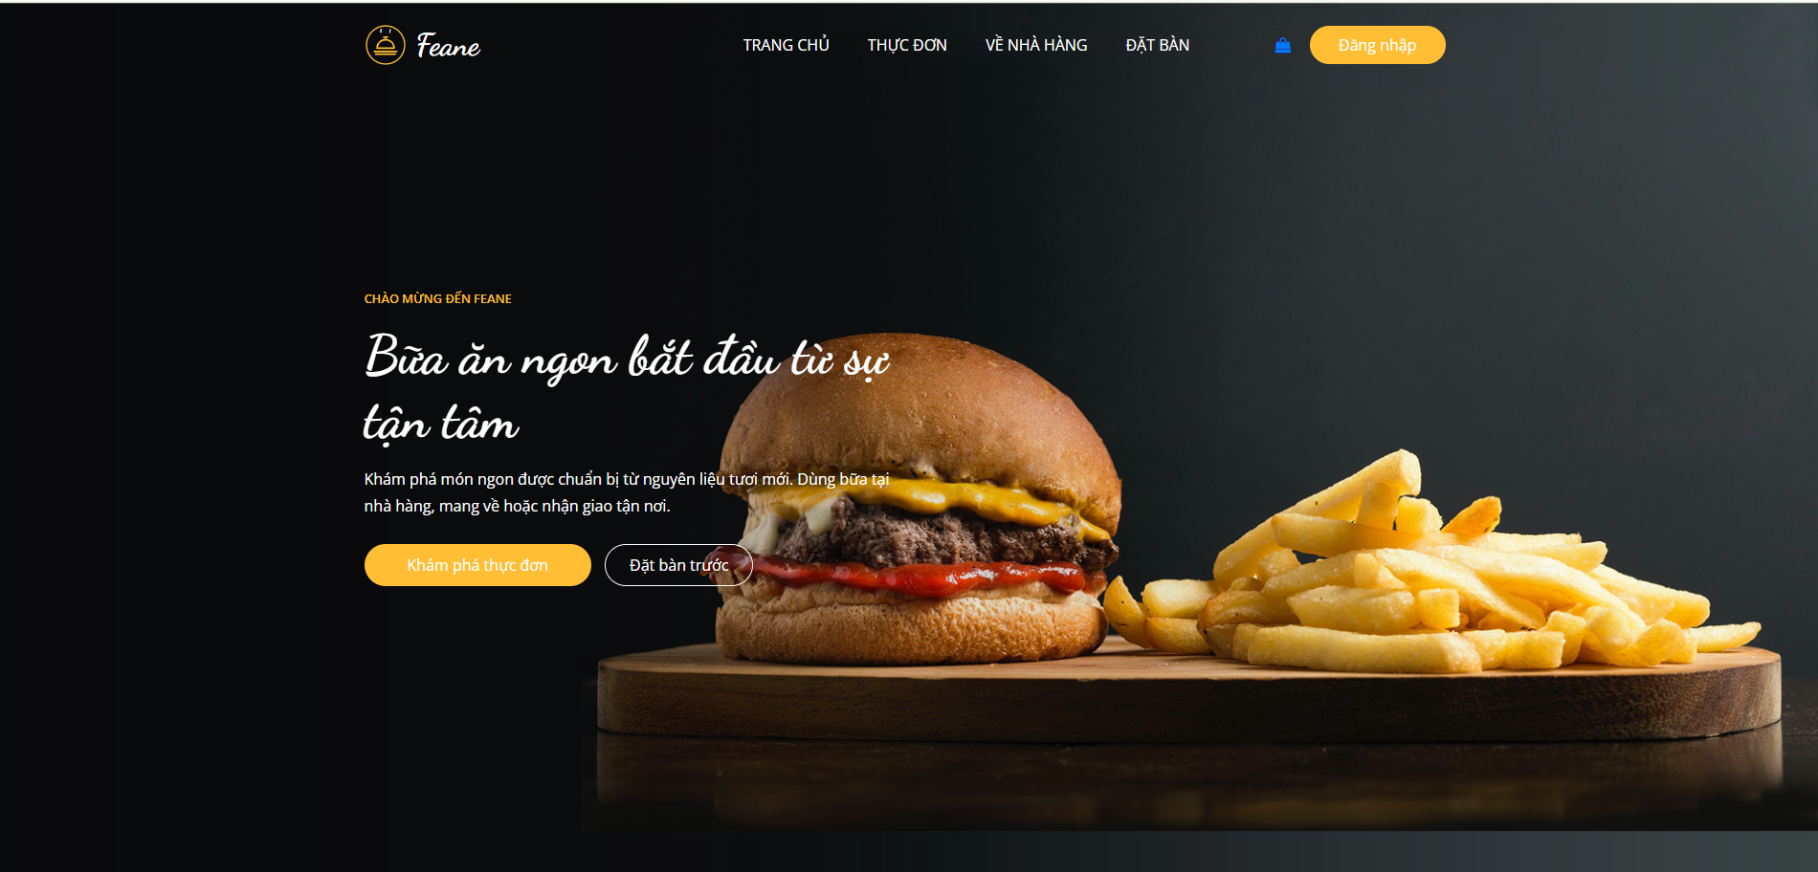
Figure 4-1: Home Page
The home page introduces Feane and provides links to the menu and table reservations. The logo, Vietnamese navigation and main banner establish the restaurant’s visual identity.
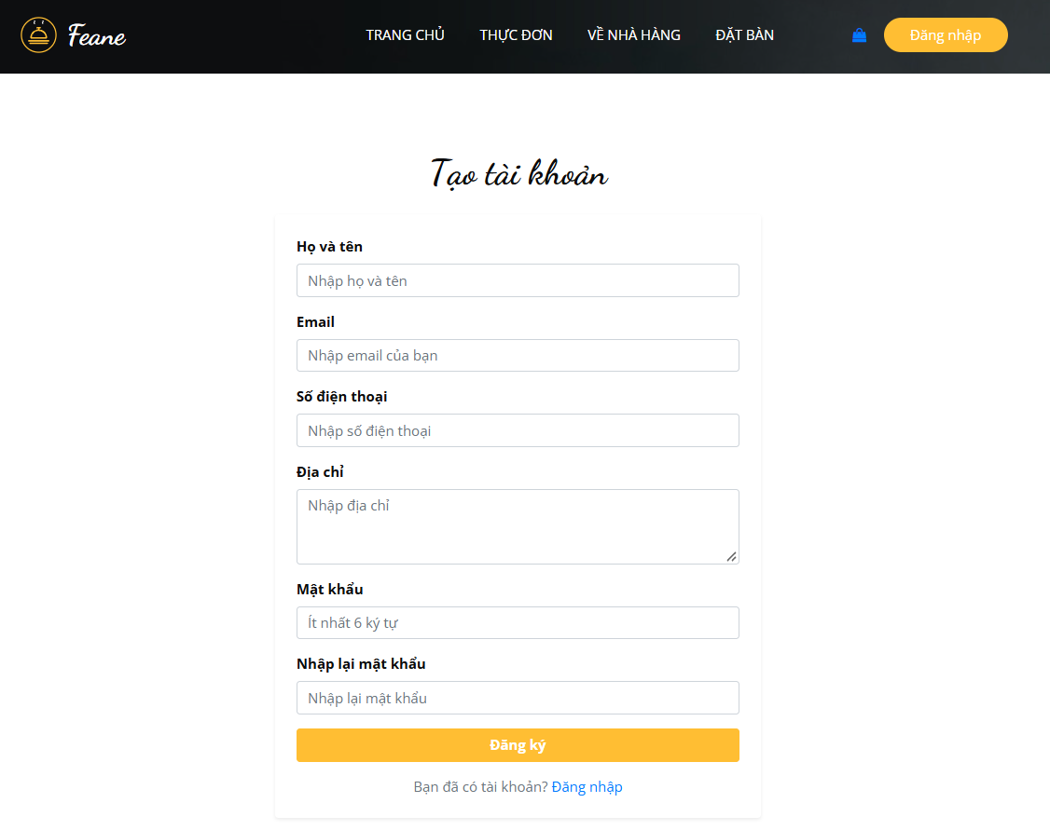
Figure 4-2: Account Registration Interface
The registration form collects the customer’s name, email, phone, address and password confirmation. Required fields and validation support customer account creation.
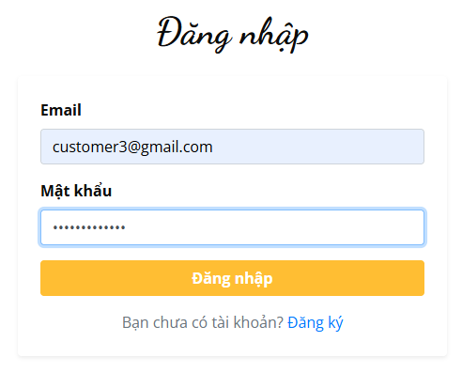
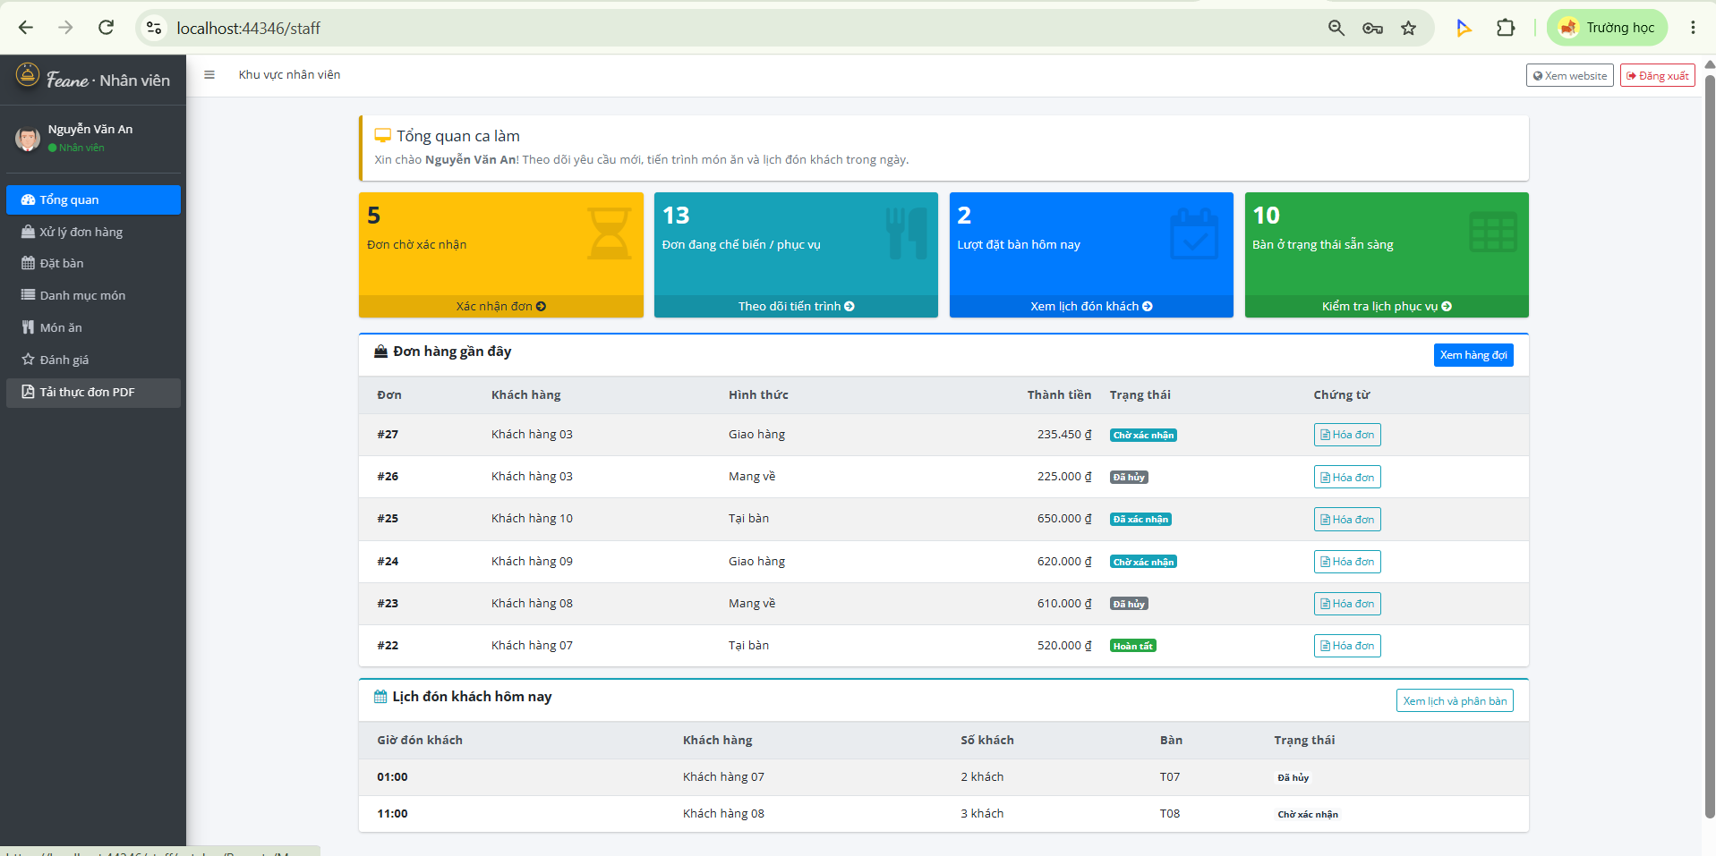
Figure 4-3: Login Interface
The login form accepts an email and password. The retained captures show the entry form and its validation response; successful login leads to the workspace associated with the account’s role.
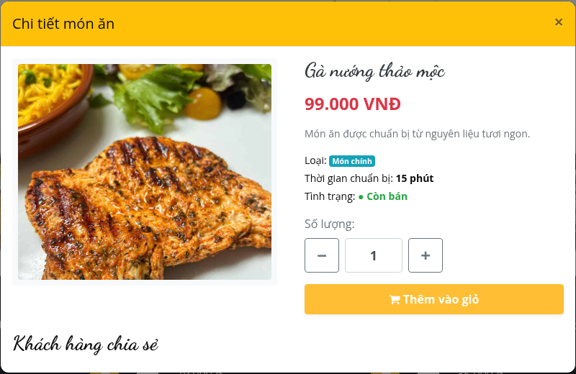
Figure 4-4: Food Details Interface
The selected dish displays its matching photograph, description and price. A signed-in customer can choose a quantity and add it to the cart. The illustrated dish is Gà nướng thảo mộc at VND 99,000.
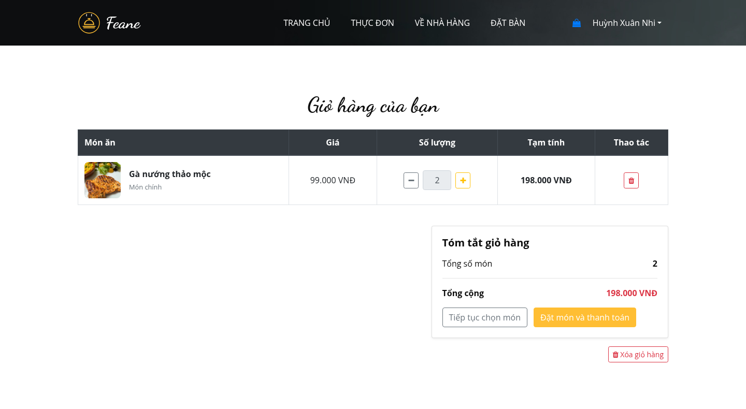
Figure 4-5: Shopping Cart Interface
The customer’s cart contains two servings of Gà nướng thảo mộc. At VND 99,000 each, the subtotal is VND 198,000. Quantity and remove controls are available before checkout.
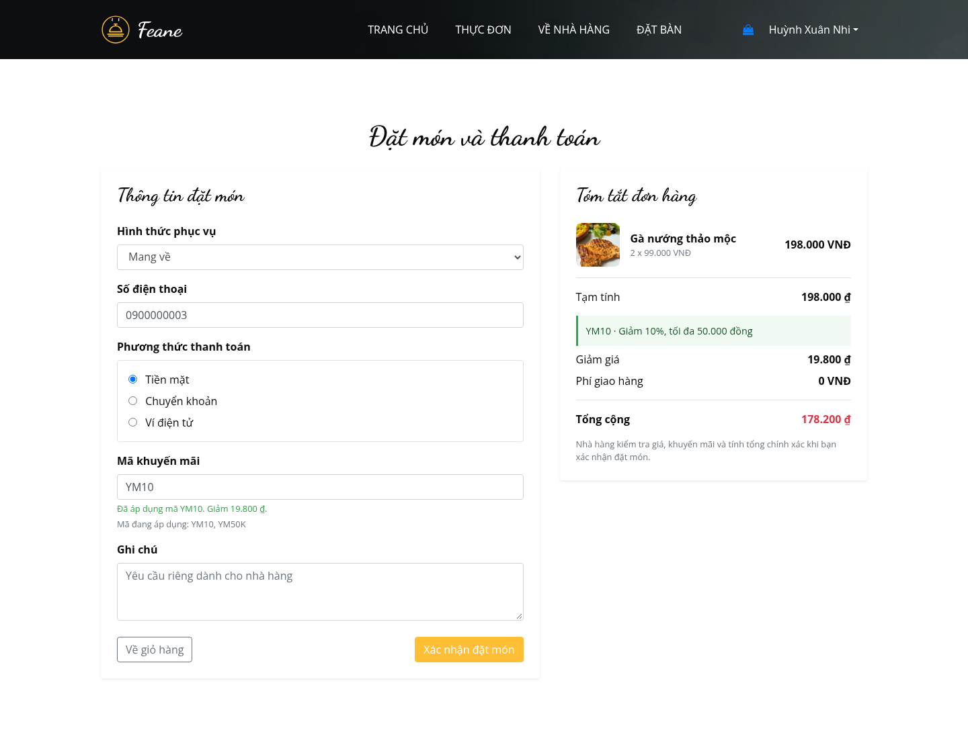
Figure 4-6: Checkout and Promotion Preview
Checkout shows a takeaway order with cash payment. Applying YM10 reduces the subtotal of VND 198,000 by VND 19,800. The summary displays the code, discount and final total of VND 178,200.
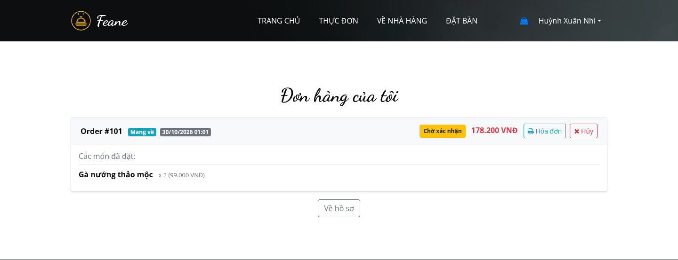
Figure 4-7: Customer Order History
The order-history screen shows illustrative order #101, its dishes and total of VND 178,200. Pending status and the permitted cancellation action are visible for the customer account.
(a) Reservation form
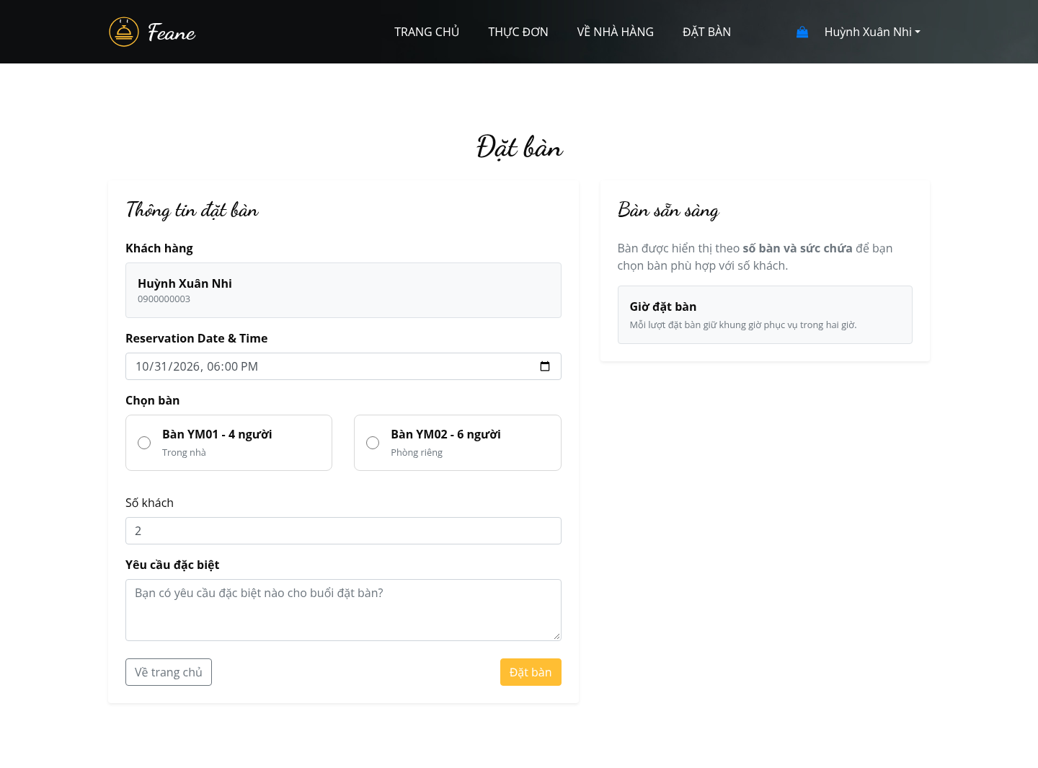
(b) Reservation history
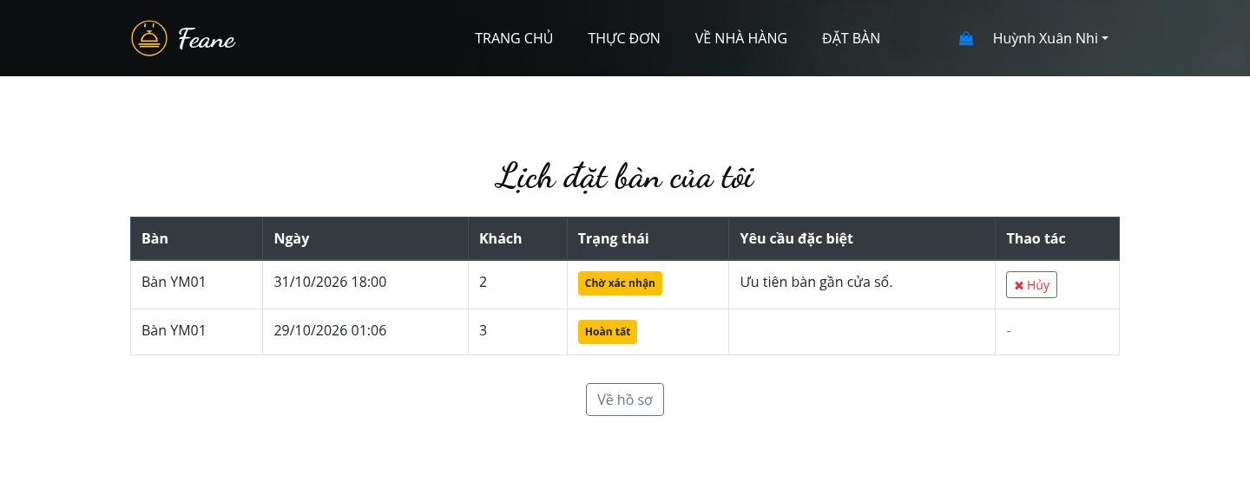
Figure 4-8: Table Reservation and Reservation History
The reservation form collects a service time, table and party size. The history screen shows the customer’s bookings and their current statuses. These illustrations use Huỳnh Xuân Nhi as the customer.
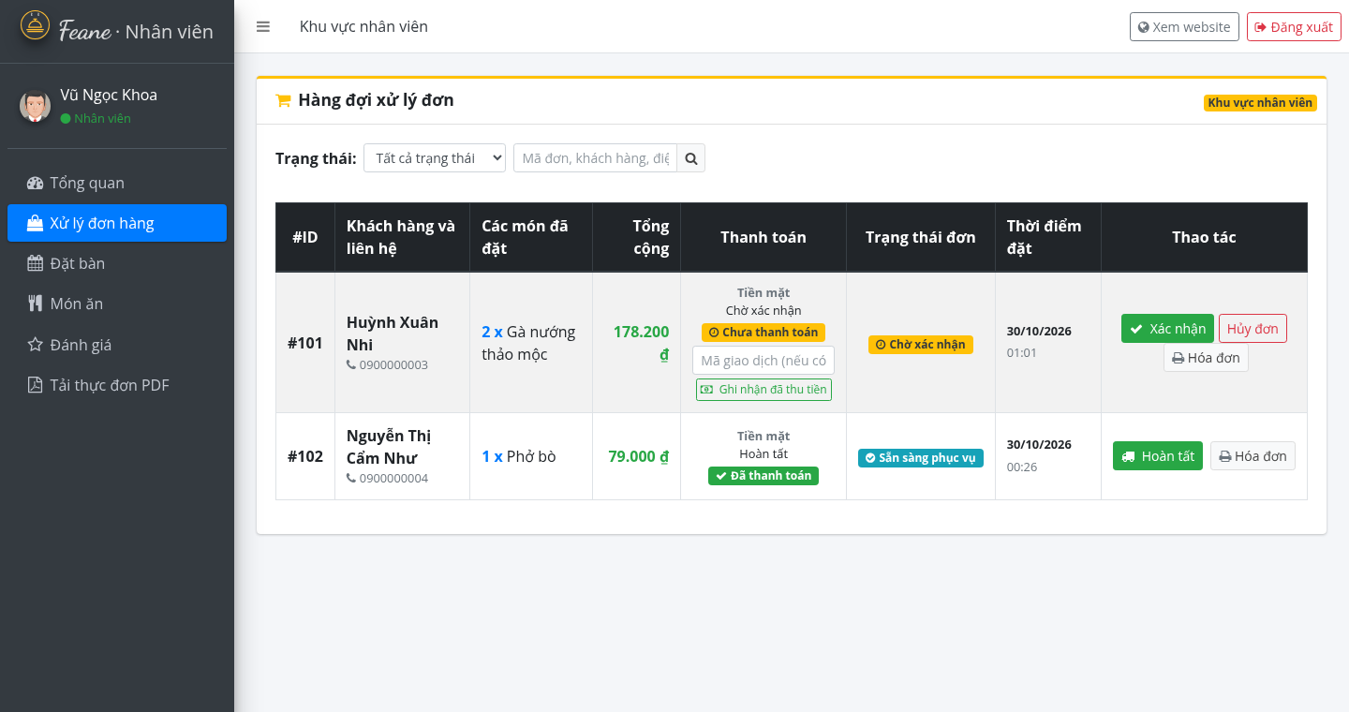
Figure 4-9: Staff Order Management Interface
Vũ Ngọc Khoa’s staff workspace shows pending order #101 and a paid order ready for completion. Order-status controls, payment recording and receipt access are grouped in the order table. Category management is absent from the staff menu.
(a) Administrator catalogue
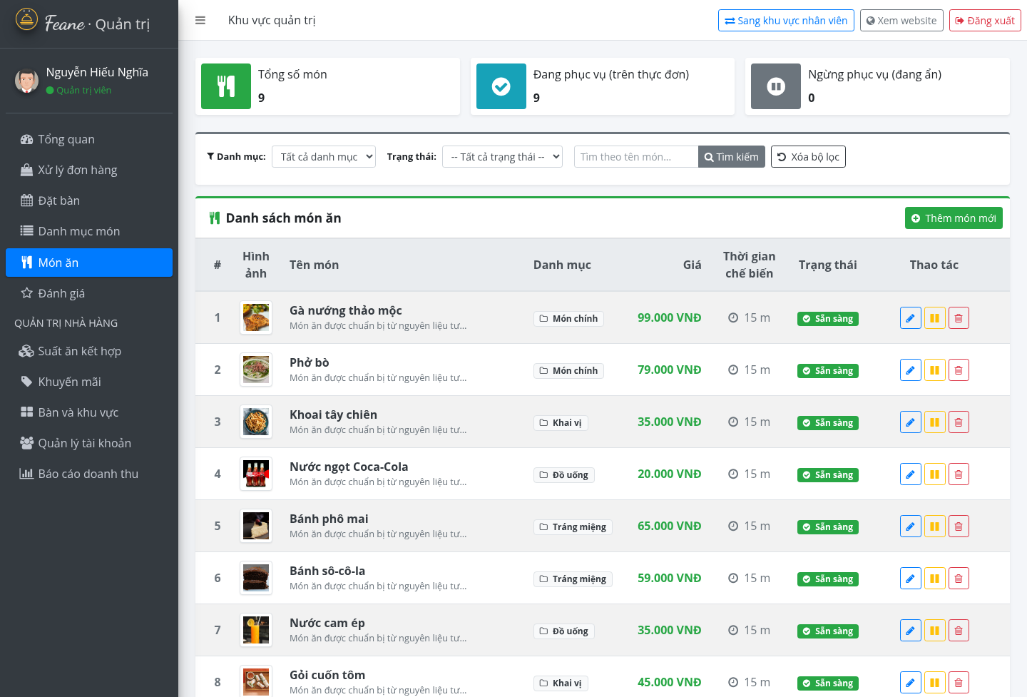
(b) Staff availability
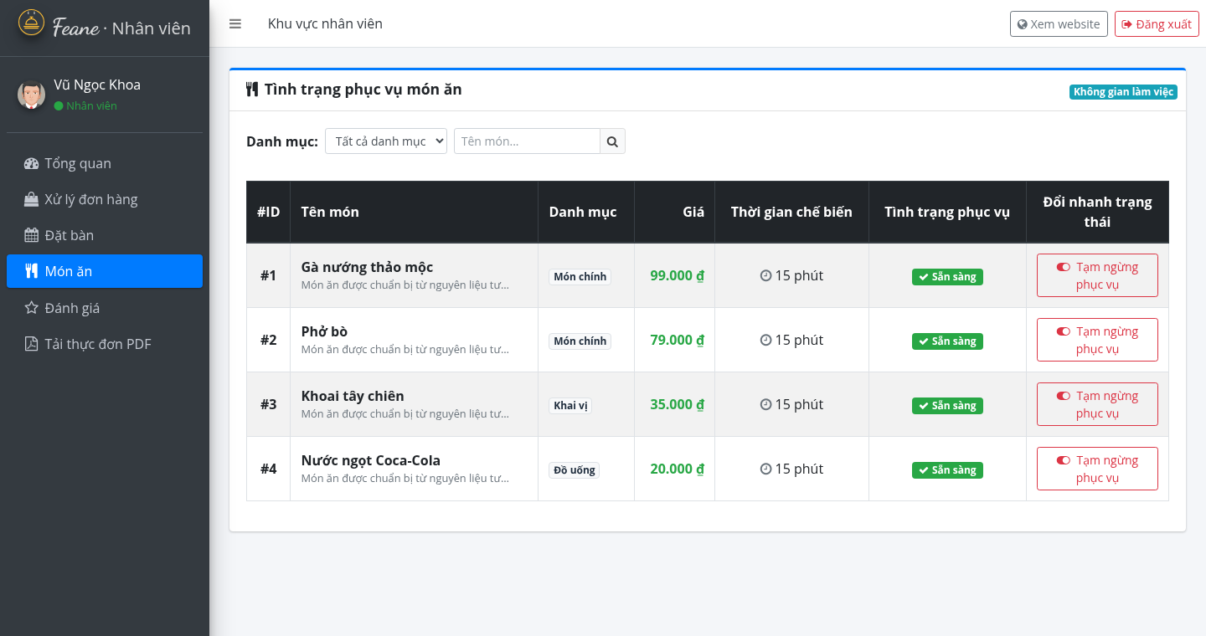
Figure 4-10: Administrator Catalogue and Staff Availability
The administrator catalogue provides dish creation, editing and protected management actions. The staff screen is limited to pausing or resuming service. Staff cannot add, edit or delete dishes, change their images or manage categories.
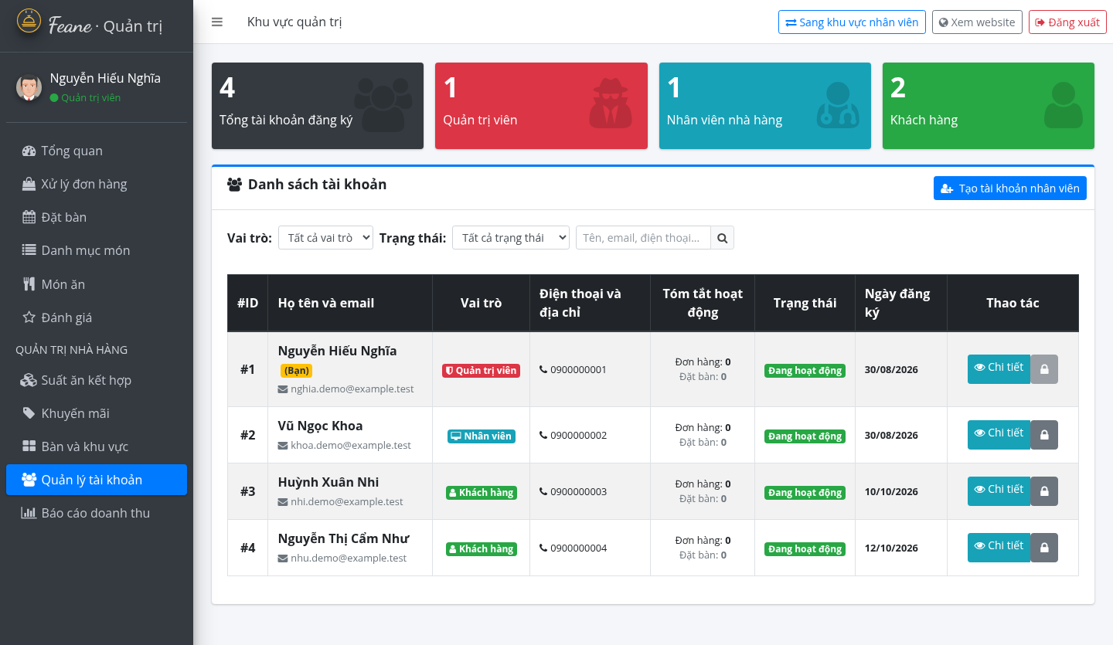
Figure 4-11: Administrator User Management
Nguyễn Hiếu Nghĩa’s administrator screen lists the four illustrative accounts. The page provides account viewing, locking/unlocking and staff creation. The account-detail workflow also provides the permitted password-reset action.
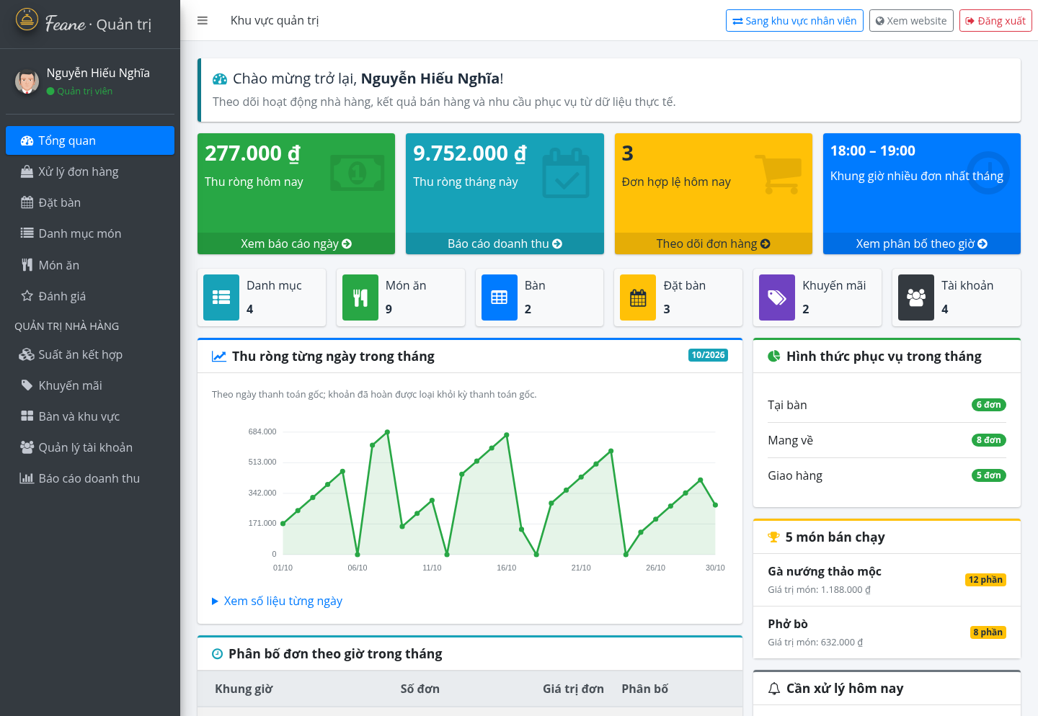
Figure 4-12: Administrator Overview
The overview combines revenue cards, a daily trend, order-type distribution and popular dishes. The administrator can open the related management pages and switch to the staff workspace from the navigation bar.
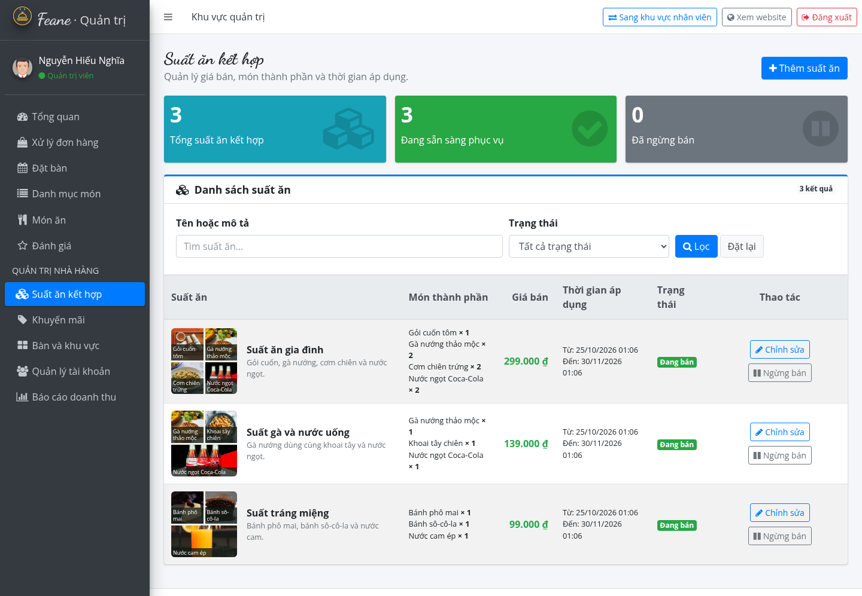
Figure 4-13: Combo Management
The combo list shows the family, chicken and dessert sample meals, their prices, components and validity dates. The pictures match the component dishes. Administrator controls support editing and changing sales availability.
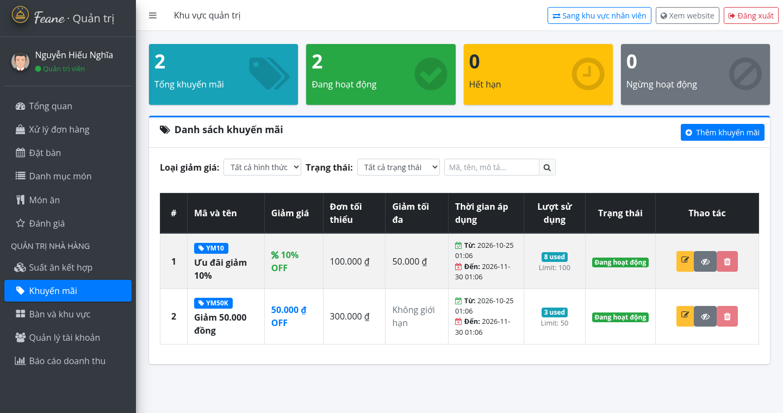
Figure 4-14: Promotion Management
The promotion list displays YM10 and YM50K with their discount types, conditions, dates and usage information. The YM10 entry corresponds to the illustrative checkout preview in Figure 4-6.
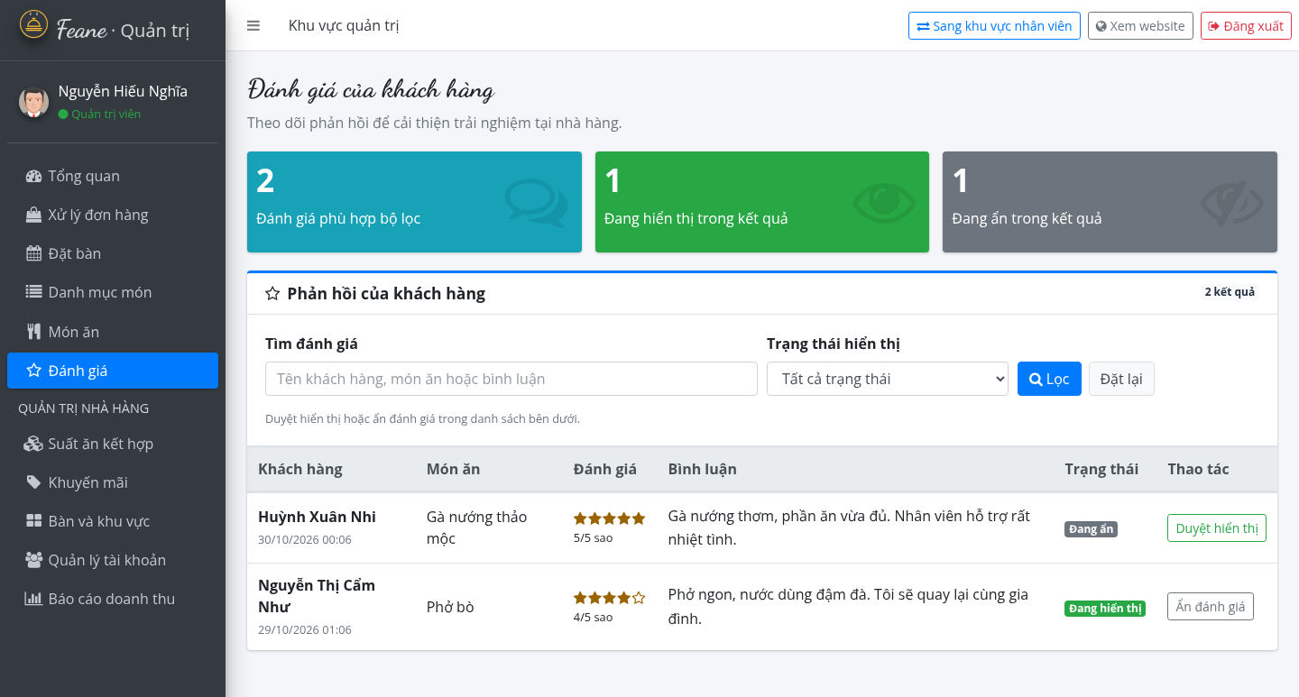
Figure 4-15: Administrator Review Moderation
The administrator can filter customer feedback and approve or hide reviews. Huỳnh Xuân Nhi and Nguyễn Thị Cẩm Như are used as the sample reviewers. Ratings, comments and visibility status are displayed together.
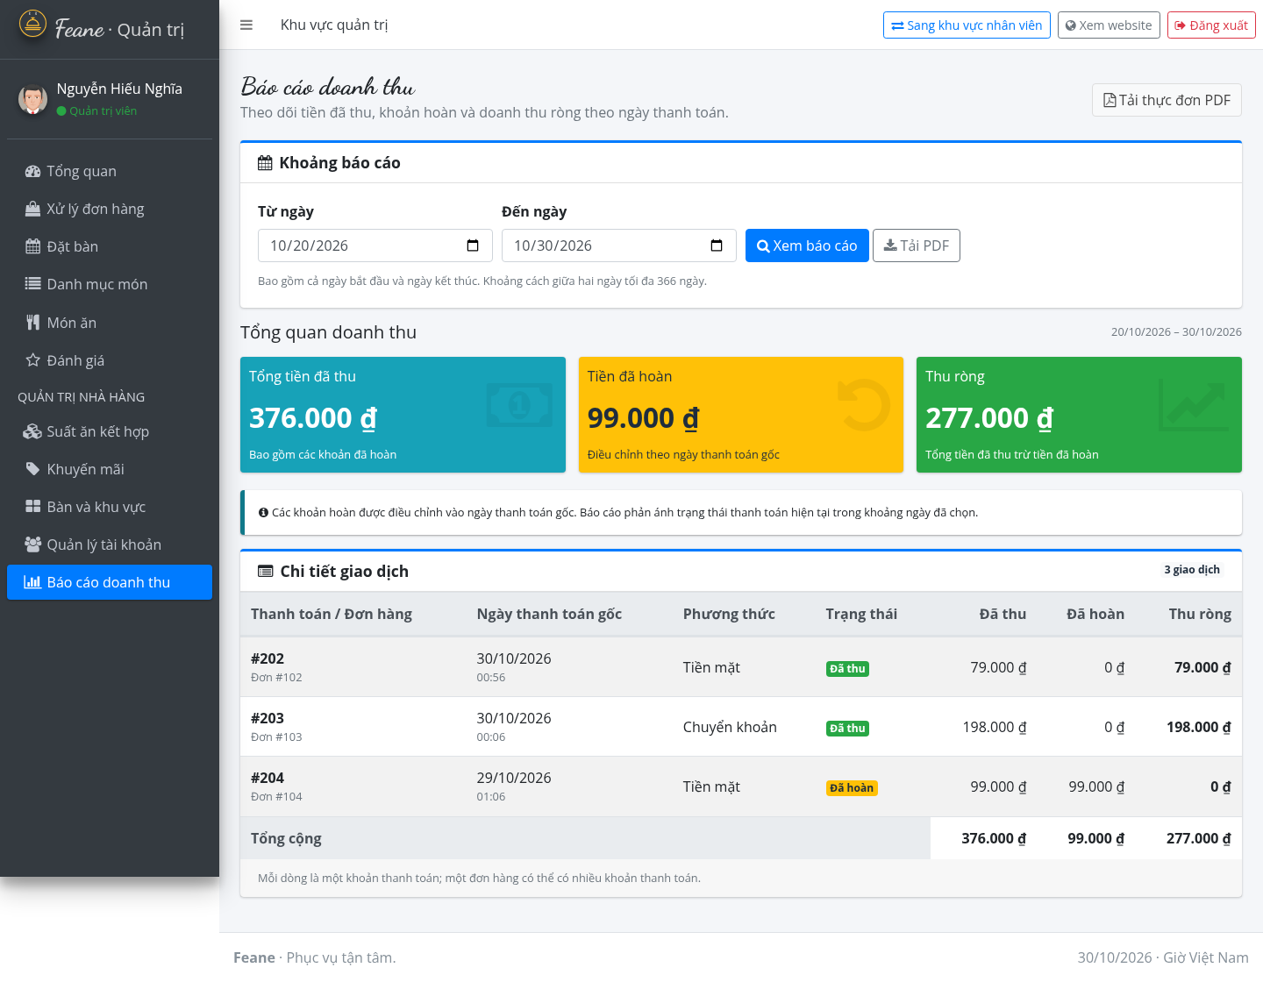
Figure 4-16: Revenue Report
The report presents collected payments, refunded amounts and net revenue for the selected dates. The sample transactions reconcile to VND 376,000 collected, VND 99,000 refunded and VND 277,000 net. PDF export remains available.
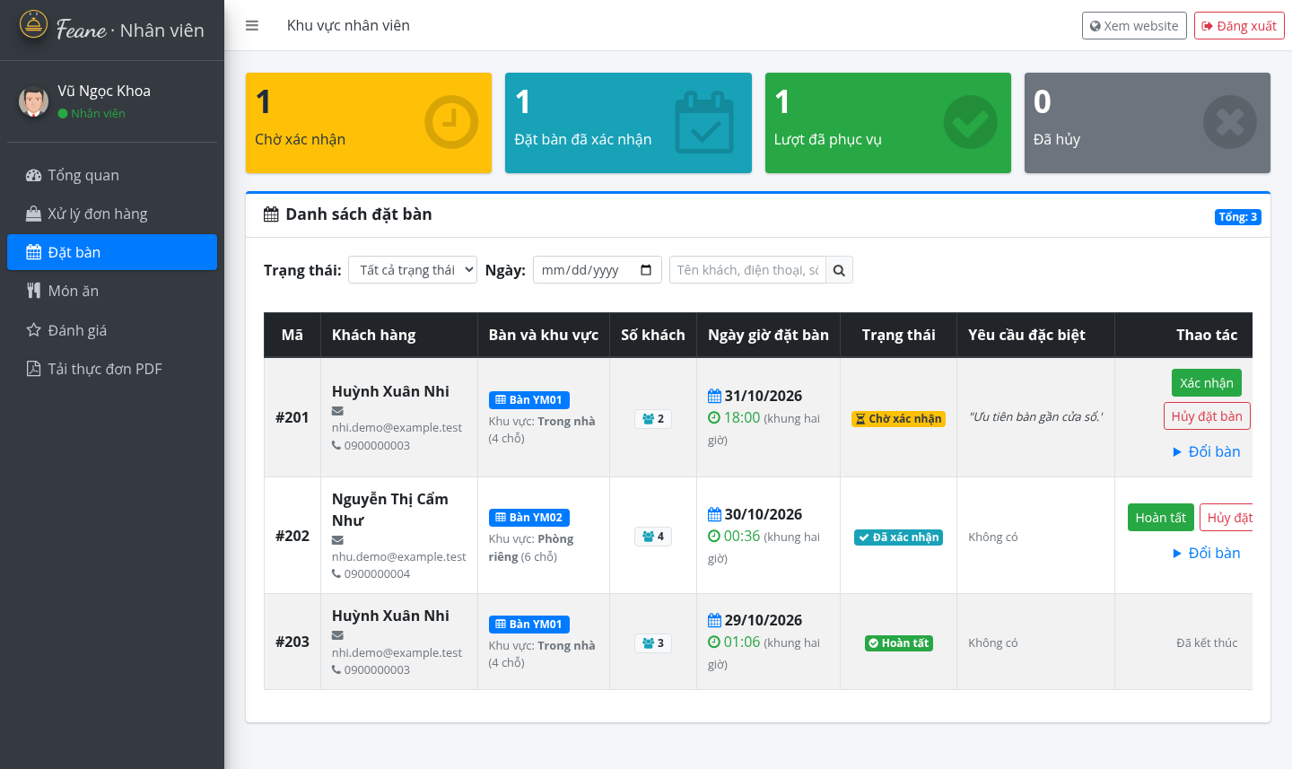
Figure 4-17: Staff Reservation Management
Vũ Ngọc Khoa’s reservation screen follows the administrator layout with status cards, filters and a booking table. Available actions include confirmation, completion, cancellation and table reassignment according to the booking’s state.
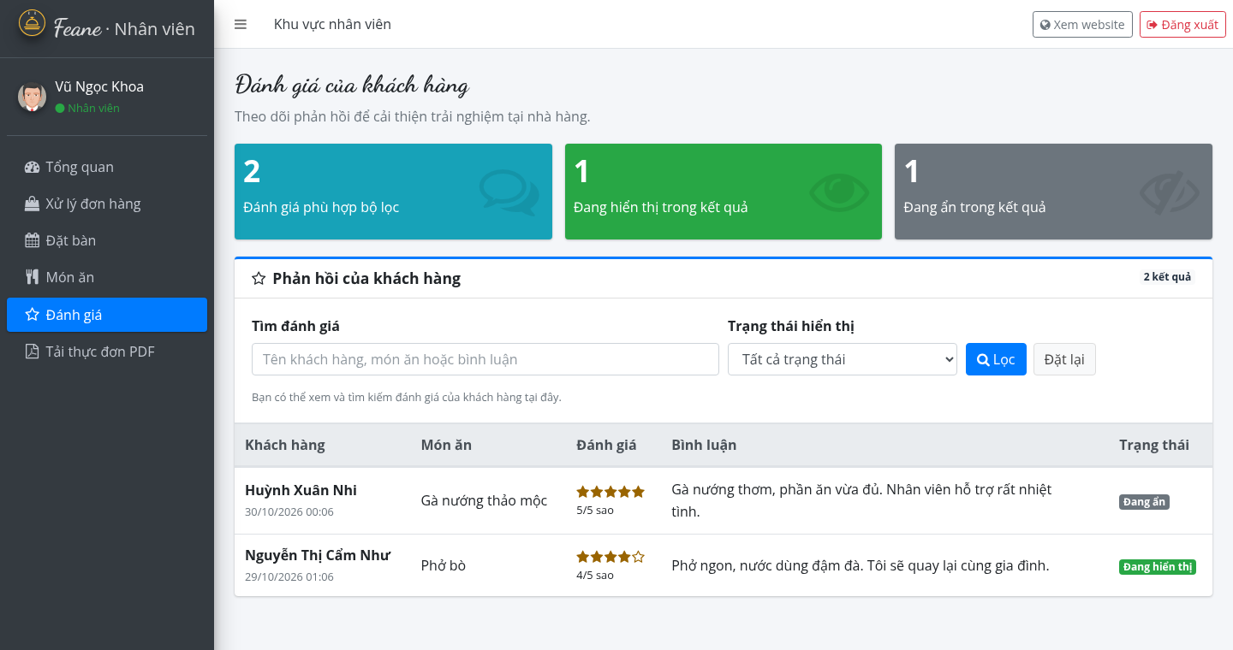
Figure 4-18: Staff Review Viewing
The staff review page supports searching and filtering the same sample feedback. Unlike the administrator page, it has no approval or hiding controls. The illustration uses Vũ Ngọc Khoa as the signed-in staff member.

CONCLUSION AND FUTURE DEVELOPMENT

Conclusion
The Restaurant and Food Order Management System was developed as a web application to support essential restaurant activities through a centralized interface. Built with C#, ASP.NET MVC 5, .NET Framework 4.8, Entity Framework 6, and Microsoft SQL Server, the project applies the Model–View–Controller pattern to organize request handling, application logic, data access, and presentation.
The project focuses on the main workflows of a restaurant website, including user account access, browsing food categories and dishes, managing a shopping cart, placing orders, making table reservations, and supporting staff or administrator operations where those functions are implemented in the current version. Role-based authorization helps separate customer activities from protected management functions.
The project also provides practical experience in developing an ASP.NET MVC application, working with a relational database, validating user input, handling web requests, and connecting views with controller actions. The testing scenarios in Chapter 4 provide a structured way to check these workflows. The final assessment of reliability and requirement coverage should be based on the recorded results from executing the scenarios against the submitted build.
Overall, the project establishes a foundation for managing key restaurant operations through a web-based system. Its usefulness depends on the accuracy of the stored data, correct authorization configuration, and successful execution of the principal customer and management workflows.

Future Development
Although the current project covers the principal workflows within its implemented scope, several improvements could be considered in future versions. These improvements should be prioritized according to user needs and the requirements approved for the next development phase.

Improve Validation and Error Handling
Input validation and error messages can be reviewed across registration, checkout, reservation, and management forms. Clearer feedback would help users correct missing or invalid information and reduce incomplete submissions.

Strengthen Security
Future work could include a review of password handling, session expiration, authorization checks, anti-forgery protection, and validation of direct URL access. Security testing should verify that users cannot view or modify records outside their assigned permissions.

Improve User Interface and Accessibility
The interface could be refined for mobile screens and different browser sizes. Consistent navigation, readable validation messages, accessible form labels, and clearer order or reservation confirmations would improve usability.

Extend Order and Reservation Tracking
The system could provide clearer status histories for orders and reservations, including timestamps for important status changes. This would help customers and restaurant staff understand the current state of each transaction.

Improve Reporting and Data Management
If required in a future scope, basic reports could summarize orders and sales using validated database records. Data backup, recovery procedures, and additional database-integrity checks could also be introduced to support more reliable operation.

Conduct Broader Testing and Deployment
Future work should include additional boundary and negative tests, browser compatibility checks, usability evaluation, and performance testing with larger datasets. The application could then be prepared for deployment in a configured hosting environment, with production database settings and operational monitoring.

REFERENCES
[Microsoft, “ASP.NET MVC Overview and Getting Started,” Microsoft Learn. [Online]. Available: https://learn.microsoft.com/en-us/aspnet/mvc/overview/getting-started/
Microsoft, “Getting Started with Entity Framework 6 Code First using MVC 5,” Microsoft Learn. [Online]. Available: https://learn.microsoft.com/en-us/aspnet/mvc/overview/getting-started/getting-started-with-ef-using-mvc/
Microsoft, “C# Language Reference,” Microsoft Learn. [Online]. Available: https://learn.microsoft.com/en-us/dotnet/csharp/language-reference/
Microsoft, “.NET Framework Documentation,” Microsoft Learn. [Online]. Available: https://learn.microsoft.com/en-us/dotnet/framework/
Microsoft, “SQL Server Technical Documentation,” Microsoft Learn. [Online]. Available: https://learn.microsoft.com/en-us/sql/sql-server/
Bootstrap Team, “Bootstrap Documentation,” Bootstrap. [Online]. Available: https://getbootstrap.com/docs/
OpenJS Foundation, “jQuery API Documentation,” jQuery. [Online]. Available: https://api.jquery.com/
GitHub, “RestaurantWebsite – Restaurant and Food Order Management System,” source code repository, branch Yamy. [Online]. Available: https://github.com/chipcao1/RestaurantWebsite/tree/Yamy
Microsoft, “Getting Started with ASP.NET MVC 5,” Microsoft Learn. [Online]. Available: https://learn.microsoft.com/en-us/aspnet/mvc/overview/getting-started/

